**Strategic Calendar & SharePoint**

**Technical Manual**

Written by SMSgt Andrew Post

Date: 25 Jan 2023

v1.2

Contents

Overview 7

The PowerApp 7

The SP Lists 7

The PowerAutomate Flows 7

Operational Theory 9

The Strat Cal SP Page 9

The User’s Flowchart/Guide 9

Theory of Operations 10

The SharePoint Lists 11

Strat Cal 11

***** 12

*** Sync 13

*** Event Tracker 14

The PowerAutomate Cloud Flows 15

***** to ** ** Strat Cal SP List 15

Step-by-Step 15

Flowchart 17

*** Sync to ** ** Strat Cal SP List 18

Step-by-Step 18

Flowchart 18

** **/*** Outlook to ** ** Strat Cal SP List 19

Step-by-Step 19

Flowchart 20

** Google to ** ** Strat Cal SP List 20

Step-by-Step 20

Flowchart 22

***** to *** Event Tracker 22

Step-by-Step 22

Flowchart 23

*** Event Tracker to *** Sync 23

Step-by-Step 23

Flowchart 24

Email and Create Folder – New Event 25

Step-by-Step 25

Flowchart 26

The ** ** Strat Cal PowerApp User Overview 27

Main Calendar Screen 27

Main Calendar Display 28

Month/Year Selector 28

Navigation/Controls 28

Day Event List 29

Display Categories/Filters 29

Filter Selection Example 30

Event Details Screen 30

Printable Calendar Screen 31

Overflowed Printable Calendar Screen Example 31

Printable Calendar Overflow Warning 31

** ** Strat Cal PowerApp Developer Overview 32

Data Elements in the App 32

Global Variables in the App 33

Media Elements in the App 34

Screens in the App 35

** ** Strat Cal PowerApp Code Elements 36

App-Level 37

App.OnStart 37

MainCalendar Screen 41

.OnVisible 41

.MoYrSelectorGroup.ALLCONTROLS.Visible 43

.MoYrSelectorGroup.btnGo.Onselect 43

.MoYrSelectorGroup.ddYear.Items 43

.MoYrSelectorGroup.ddYear.Default 43

.MoYrSelectorGroup.ddYear.Reset 44

.MoYrSelectorGroup.ddMonth.Items 44

.MoYrSelectorGroup.ddMonth.Default 44

.MoYrSelectorGroup.ddMonth.Reset 44

.MoYrSelectorGroup.btnHideMoYrSelector.OnSelect 44

.btnMoYrSelector.OnSelect 44

.btnUpdateCollections.OnSelect 44

.btnUpdatePrintCollections.OnSelect 45

.MonthDayGallery.Items 50

.MonthDayGallery.TemplateSize 50

.MonthDayGallery.Visible 50

.MonthDayGallery.lblDate.BorderColor 51

.MonthDayGallery.lblDate.BorderThickness 51

.MonthDayGallery.lblDate.Color 51

.MonthDayGallery.lblDate.Fill 52

.MonthDayGallery.lblDate.FontWeight 54

.MonthDayGallery.lblDate.OnSelect 54

.MonthDayGallery.lblDate.Text 54

.MonthDayGallery.lblDate.Visible 54

.MonthDayGallery.lblFullDate.Text 55

.MonthDayGallery.lblDayRows.Text 55

.MonthDayGallery.SelectedDayRect.Visible 55

.MonthDayGallery.lblMoreItems.Fill 55

.MonthDayGallery.lblMoreItems.Text 55

.MonthDayGallery.HolidayItemsGallery.Items 56

.MonthDayGallery.HolidayItemsGallery.btnHolidayItem.Text 56

.MonthDayGallery.DayItemsGallery.Items 56

.MonthDayGallery.DayItemsGallery.ShowScrollbar 57

.MonthDayGallery.DayItemsGallery.lblTitle.Text 57

.MonthDayGallery.DayItemsGallery.lblDayColorBar.Fill 58

.MonthDayGallery.DayItemsGallery.lblDayColorBar.Height 58

.MonthDayGallery.DayItemsGallery.lblDayColorBar.Visible 58

.MonthDayGallery.DayItemsGallery.lblDayColorBar.Width 59

.MonthDayGallery.DayItemsGallery.lblDayColorBar.Y 59

.HeaderGroup.IconSubmit.OnSelect 59

.HeaderGroup.IconPrint.OnSelect 59

.HeaderGroup.IconToday.OnSelect 59

.HeaderGroup.IconRefresh.OnSelect 60

.HeaderGroup.IconNextMonth.OnSelect 61

.HeaderGroup.IconPrevMonth.OnSelect 61

.HeaderGroup.WeekDayGallery.Items 62

.HeaderGroup.WeekDayGallery.lblWeekdayTitle.Text 62

.HeaderGroup.lblMonthSelected.Text 62

.FilterCategoriesGroup.btnInvert.OnSelect 62

.FilterCategoriesGroup.btnNone.OnSelect 63

.FilterCategoriesGroup.btnAll.OnSelect 63

.FilterCategoriesGroup.Checkbox1_##.OnCheck 63

.FilterCategoriesGroup.Checkbox1_##.OnUncheck 63

.FilterCategoriesGroup.Checkbox1_##.Default 63

.FilterCategoriesGroup.Checkbox1_##.Reset 64

.FilterCategoriesGroup.Checkbox1_##.Fill 64

.FilterCategoriesGroup.Checkbox1_##.Text 64

.RightBarGroup.lblSelectedDayGallery.Text 64

.RightBarGroup.SelectedDayHolidayGallery.Items 64

.RightBarGroup.SelectedDayHolidayGallery.Height 65

.RightBarGroup.SelectedDayGallery.Height 65

.RightBarGroup.SelectedDayGallery.Y 65

.RightBarGroup.SelectedDayGallery.OnSelect & SelectedDayHolidayGallery.OnSelect 65

.RightBarGroup.SelectedDayGallery.lblColorBar.Fill & SelectedDayHolidayGallery.lblColorBar_1.Fill 65

.RightBarGroup. SelectedDayGallery.lblEventTitle.Text & SelectedDayHolidayGallery.lblEventTitle_1.Text 66

.RightBarGroup.SelectedDayGallery.lblDateTime.Text 66

CalendarItemDetails Screen 67

.lblColorBarTop.Fill & lblColorBarMain.Fill 67

.iconBack.OnSelect 67

.lbl.EventTitle.Text 67

.FormViewer1.*_DataCard1 67

.GpPatch.Image 68

PrintCalendar Screen 69

.OnVisible 69

.WarningBoxCtnr.ALLCONTROLS.Visible 69

.WarningBoxCtnr.btnWarning.OnSelect 69

.WeekGalleriesGroup.WeekDayGallery_#.Items 70

.WeekGalleriesGroup.WeekDayGallery_#.lblMaxRows_#.Text 70

.WeekGalleriesGroup.WeekDayGallery_#.lblDate_#.Text 70

.WeekGalleriesGroup.WeekDayGallery_#.lblDate_#.Visible 70

.WeekGalleriesGroup.WeekDayGallery_#.lblValue_#.Text 71

.WeekGalleriesGroup.WeekDayGallery_#.lblTargetWeekOrder_#.Text 71

.WeekGalleriesGroup.WeekDayGallery_#.lblWeekNum_#.Text 71

.WeekGalleriesGroup.WeekDayGallery_#.lblDayRows_#.Text 71

.WeekGalleriesGroup.WeekDayGallery_#.DayItemsGallery_*****_#.Height 71

.WeekGalleriesGroup.WeekDayGallery_#.DayItemsGallery_*****_#.lblTitle_#.Text 71

.WeekGalleriesGroup.WeekDayGallery_#.DayItemsGallery_*****_#.lblOrder_#.Text 72

.WeekGalleriesGroup.WeekDayGallery_#.DayItemsGallery_*****_#.lblDayColorBar_#.Fill 72

.WeekGalleriesGroup.WeekDayGallery_#.DayItemsGallery_*****_#.lblDayColorBar_#.Height 72

.WeekGalleriesGroup.WeekDayGallery_#.DayItemsGallery_*****_#.lblDayColorBar_#.Width 73

.WeekGalleriesGroup.WeekDayGallery_#.DayItemsGallery_*****_#.lblDayColorBar_#.Y 73

.WeekGalleriesGroup.WeekDayGallery_#.DayItemsGallery_*****_#.thruLineEndRect_#.Width 73

.WeekGalleriesGroup.WeekDayGallery_#.DayItemsGallery_*****_#.thruLineEndRect_#.Height 73

.WeekGalleriesGroup.WeekDayGallery_#.DayItemsGallery_*****_#.thruLineRect_#.X 74

.WeekGalleriesGroup.WeekDayGallery_#.DayItemsGallery_*****_#.thruLineRect_#.Width 74

.HeaderGroup_1.iconPrint_1 74

END 75

**Foreword:** This “technical manual” will, hopefully, explain in some level of detail how the 86th Airlift Wing Strategic Calendar (strat cal) PowerApp and associated PowerAutomate flows and SharePoint (SP) lists work. It will include as much technical detail as possible to help with troubleshooting and operation.

# Overview

## **The PowerApp**

The calendar is a Microsoft (MS) PowerApp built on the enterprise PowerPlatform. There are code elements involved in its operation that will be detailed later in this manual. The PowerApp uses a SP connection to gather event data. Data populates the SP list using a combination of PowerAutomate flows and manual input. The SP connection must be moved to successive *** and/or Comm Sq members as the positions are filled with new personnel. Additionally, the PowerApp itself must have permissions updated to allow new personnel to edit/co-own. **WARNING: As of this writing, PowerApps cannot move full ownership to new users. This may cause issues when the current owner’s account is removed from the enterprise (retirement, etc.). In that case, it may be necessary to re-deploy the PowerApp.**

## The SP Lists

Linked below, the 86AW ***** and the *** Sync automatically populate the strat cal SP list under certain conditions (see the PowerAutomate Flows). The ***** should be the source for the vast majority of events on the strat cal. Automated flow from the *** Sync is only for events that will not have Project Officers (projos) outside of the ***, but are deemed strategic in nature, and require manually checking the “Push to Strat Cal” box.

* ***** Link
* *** Sync Link

The main strat cal SP list is linked below. It is where the strat cal PowerApp gathers data for display. The strat cal PowerApp **only** gathers data from the list at this link. All other data must feed this list to appear on the strat cal. Finally, items may be manually added to the list.

* Strat Cal Link

The *** Event Tracker SP list is linked below. It is where projos can work on their projects. By default, any event added to the *** Event Tracker will be automatically pushed to the *** Sync SP list. ***** items with the “Strategic (** ** Use Only)” box checked, and approved, will populate both the strat cal SP list and *** Sync SP list.

* *** Event Tracker Link

## The PowerAutomate Flows

There are three PowerAutomate cloud flows that manage automatic population of the strat cal SP list. All of the flows are co-owned by the current *** personnel, and **always** the 86 CS/SCXK shop. The 86 CS/SCXK shop is the continuity of permissions for the flows. Permissions need to be updated during turnover of *** personnel.

* “***** to ** ** Strat Cal SP List” handles events added via the ***** SP list.
* “*** Sync to ** ** Strat Cal SP List” handles events added to the *** Sync SP list that are deemed strat cal events.
* “** Google to ** ** Strat Cal SP List” handles events from **’s Google Calendar that ** deems strat cal events.

There are a few additional PowerAutomate cloud flows that relate to, but do not directly affect the strat cal. These will also be covered in this manual because I don’t know where else to put the info. Below are the additional PowerAutomate flows:

* “***** to *** Event Tracker” creates events on the *** Event Tracker SP list when a ***** item is both approved and marked as strategic by *** personnel checking the “*** Strategic (** ** Use Only)” box.
* “*** Event Tracker to *** Sync” copies any item placed on the *** Event Tracker SP list onto the *** Sync SP list. Additionally, updates the *** Sync when changes are made to the *** Event Tracker (this is in the case that the event is not sourced from the *****, i.e. a manual addition).
* “Email and Create Folder – New Event” creates storage space on the *** SP site and emails the projos information about the SP site when a new *** Event Tracker event is updated with projo names.
* “Email – Projo Change” resends the information email to all projos when any projo name is changed (new add, remove, etc.).

# Operational Theory

## The Strat Cal SP Page

Located at the link below, this page is where customers are directed to view and use the strat cal. It has an embedded flowchart as well as an embedded instance of the strat cal PowerApp.

Strat Cal SP Page Link

## The User’s Flowchart/Guide

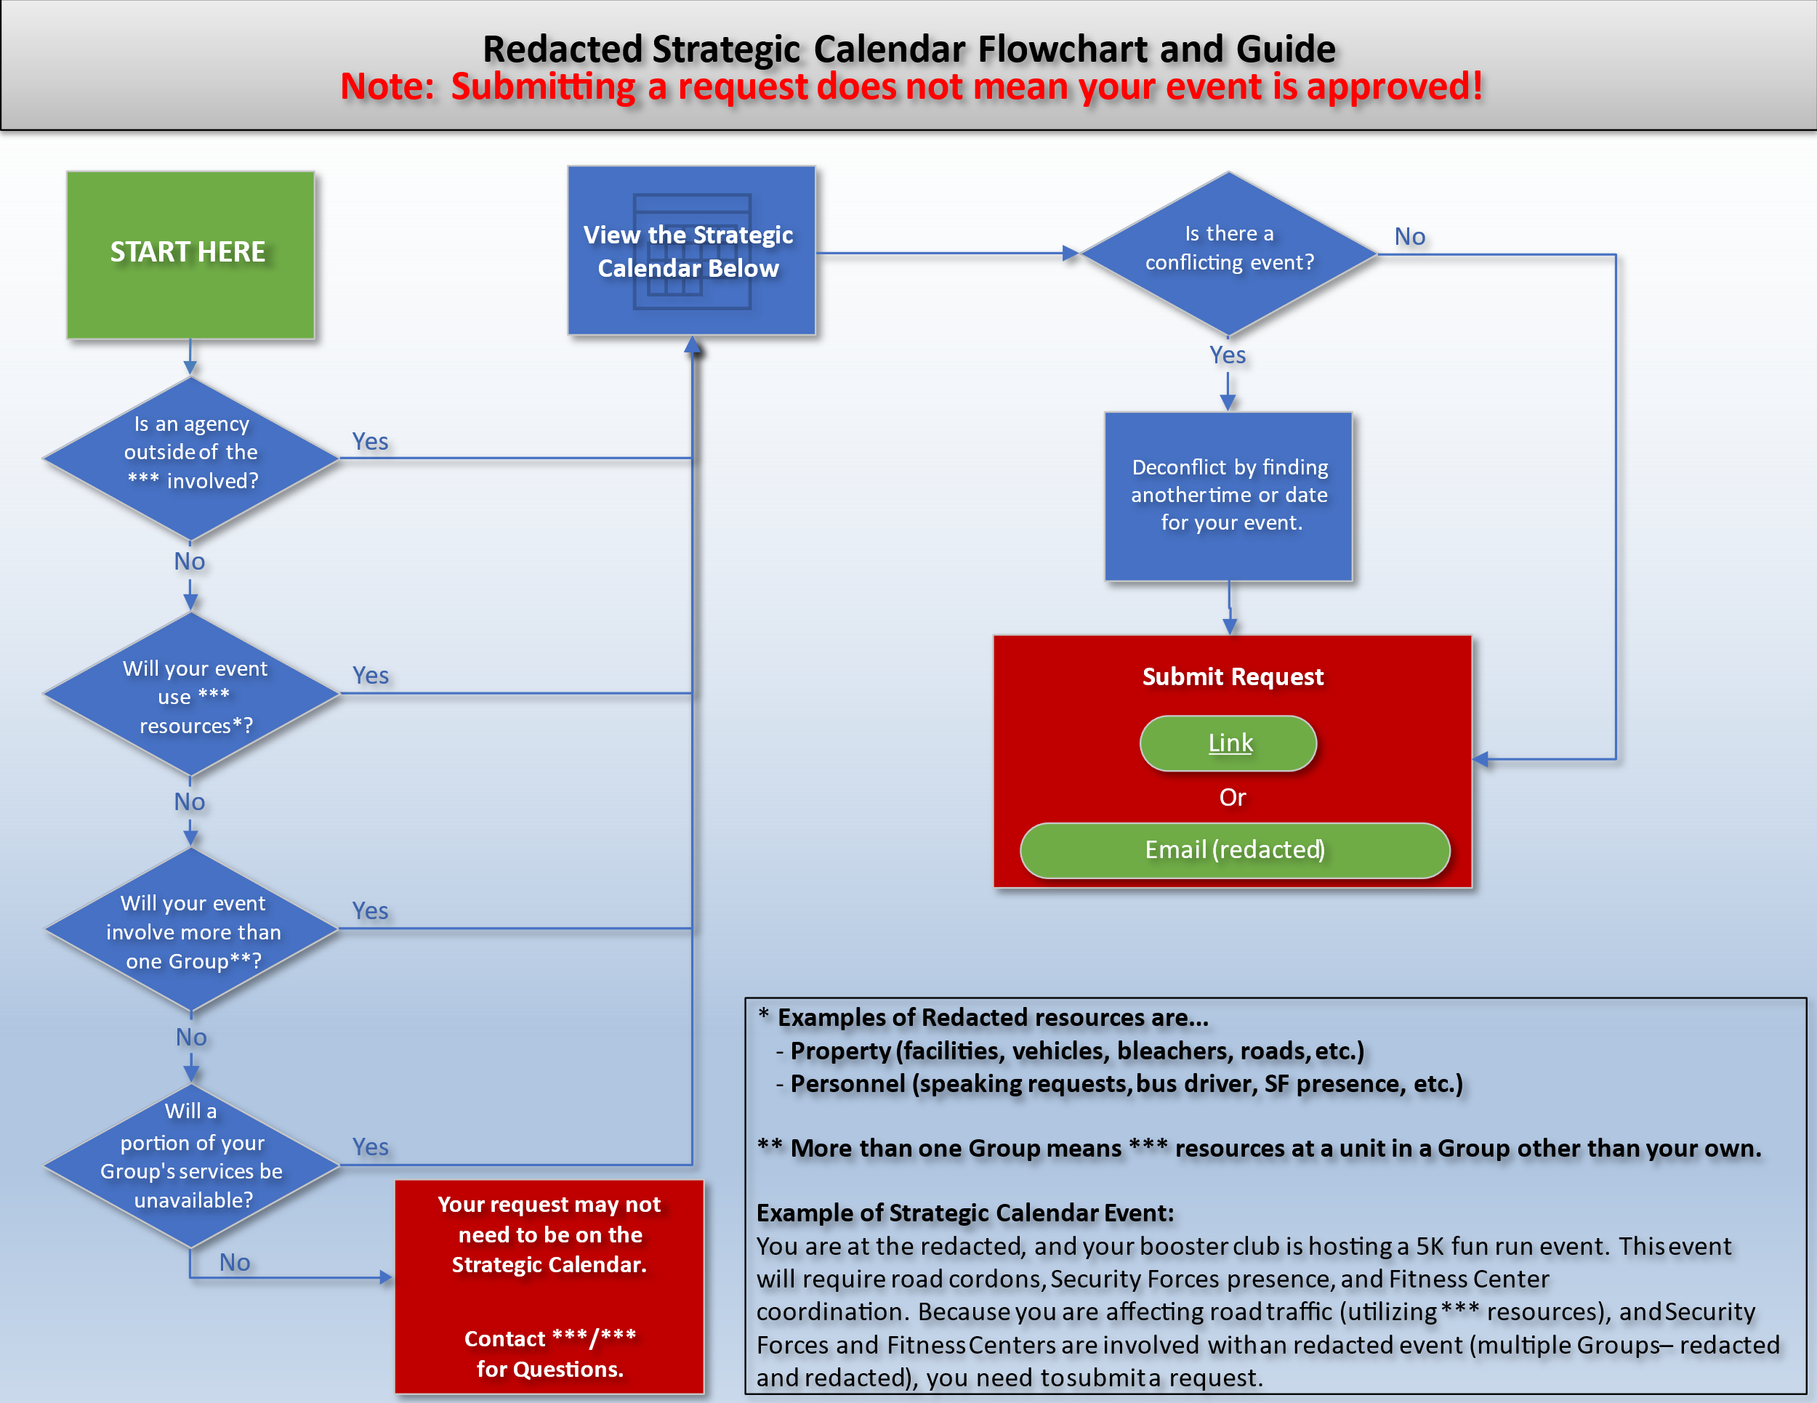

The flowchart above is on the is the customer’s main guide on whether or not to request a new event for the strat cal. The PowerPoint slide can be edited/downloaded here:

Flowchart PowerPoint Link

## Theory of Operations

1. Once a customer has determined that their event should be on the strat cal from reading/following the flowchart, they are directed to a form to submit a ***** request
   1. New requests are automatically placed into “New Request” status
2. The ** ** ***** will place it into “Pending” status upon their initial review
3. The ** ** *** will further review (currently delegated from ** **/CC) any “Pending” ***** requests and update their status as needed – generally to “Approved”
   1. Options are: Approved, Canceled, Postponed, and Completed
   2. Additional option to check “Strategic (** ** Use Only)” is available to the ***
      1. Selecting this option, activates an additional PowerAutomate flow that will populate the *** Event Tracker SP list and the *** Sync SP list
4. Upon changing the status and saving the item on the ***** SP list, the “***** to ** ** Strat Cal SP List” PowerAutomate flow will check if the event already exists by using the ***** SP list item **GCID** and deterministically create, update, or delete the corresponding item on the strat cal SP list
   1. If status is changed to “Approved”
      1. The flow will copy the event info into a new item in the strat cal SP list
   2. If status is changed to “Canceled”
      1. The flow will delete the corresponding item in strat cal SP list
   3. If status is changed to “Postponed”
      1. The flow will delete the corresponding item in strat cal SP list
5. If the event already exists on the strat cal SP list, the PowerAutomate flow will update the strat cal SP list with any changes made to the ***** item
   1. Customers are encouraged to update their ***** requests as necessary should any changes occur

**Note:** Items deleted from the ***** or *** sync SP lists will NOT activate any flows to delete the corresponding item on the strat cal SP list. Without higher permissions in the enterprise, you cannot create a flow that is triggered by a deletion.

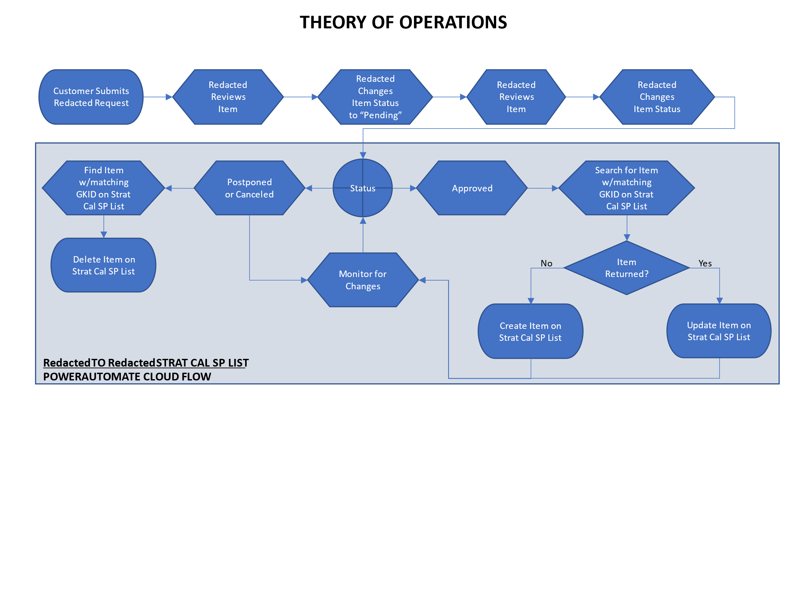

# The SharePoint Lists

For the sake of everyone’s sanity, when in reference to SP lists in this document, “columns” are the same as form entry boxes on any list. I.E., when you input text in a textbox named “Title,” the name “Title” is actually the name of the column that data will occupy in the list.

## Strat Cal

Strat Cal Link

This is where the strat cal PowerApp gathers data for display. The strat cal PowerApp **only** gathers data from this list. All other data must feed this list to appear on the strat cal. Finally, items may (must) be manually added to the list (must: holidays and family days). Below are column descriptions and how they influence the PowerApp.

* **Title**
  + Self-explanatory. This is what is displayed when viewing the PowerApp as a calendar.
* **Start Date**
  + Self-explanatory. This is both a date and time. Dates/times appear as the time zone that the SP is set to (not the computer’s time zone), but are stored on the server as UTC. This distinction is important to understand for background workings of SP, PowerAutomate, and PowerApps. Additionally, zero-length days (identical start date/time and end date/time) are interpreted by the ** ** Strat Cal PowerApp as single-day all-day events.
* **End Date**
  + Self-explanatory. See extra notes with **Start Date**.
* **Location**
  + Location of the event if it is necessary and/or exists.
* **Description**
  + Self-explanatory.
* **Group**
  + This column’s background SP title is **GroupCategory**. It will be referenced by both throughout this document, but **GroupCategory** is the only way the PowerApp will reference this column. This column tells the PowerApp which category/color that the item should display. If a list item has no data, or data that does not match the specific categories listed below, it will NOT appear in the PowerApp. The data in the **GroupCategory** column must match *verbatim* the categories, including typecase. Note, family days and holidays are treated as the same category: “Holiday.” The specific categories are:
    - ** **, ** **, ** **, ** **, ** **, ** **, ** **, ** **, ** **, **, Inspections, Audits, Non-** **, Holiday
* **GKID**
  + This stands for ***** ID. This column is only used by the PowerAutomate flows to uniquely identify events that propagated from the ***** SP list. It does not directly affect the operation of the PowerApp.
* **Length**
  + This column was in use in the PowerApp to provide an already-calculated day-length of an event. It is currently unused.

## *****

***** Link

The ** ** *****s are the owners of this SP list. There are 8 columns discussed here that are important to the PowerAutomate flows and the strat cal PowerApp (more of them are important to *** business practices, but those are beyond the scope of this document). It should be noted that items deleted from the ***** SP list will NOT be deleted from other lists. PowerAutomate only allows higher-permissioned users to trigger flows on a delete action. Items with statuses set to Canceled or Postponed WILL delete from the other lists.

* **Title**
  + This column will copy across all lists as **Title** or **Event Subject**. Often, ***** requests come in with less-than-descriptive titles (i.e., “Base Tour”) and should be edited by *** personnel to be better-descriptive (i.e., “Base Tour for **** Members”) as it will display on the PowerApp’s calendar view. In the case of being considered “strategic” by checking the **Strategic (** ** Use Only)** checkbox, it will also be used as a folder name on the *** SP site. Special care must be taken to ensure illegal characters (< > : “ / \ | ? *) are not in this column before marking a ***** item as strategic.
* **Type of Activity**
  + This column is checked for “Inspections” and “Audits” to properly categorize them for display on the PowerApp. If either word is detected, a flow will ensure the strat cal SP list **GroupCategory** column is correctly filled. In all other cases, the data from the **Hosting Org/Group** column will propagate to the **GroupCategory** column.
* **Begin/End Date**
  + Self-explanatory. Ensure the end date is AFTER the begin date. ***** requests often have mistaken am/pm for the end date (12:00 am instead of 12:00 pm).
* **Purpose and Description of Visit**
  + This column will copy across all lists that need **Description** information. It is especially important to know that this information will display on the strat cal in event details. Formatting, language, and TMI should be considered when reviewing this column.
* **Hosting Org/Group**
  + This column is extremely important because it feeds the strat cal SP list **GroupCategory** column which controls which category/color it displays in the PowerApp, or if the event displays at all. Check for accuracy often (** likes to select “Non-** **” for ** base tours). This column is overridden in three cases:
    - **Type of Activity** contains “Inspections” (overridden to “Inspections”)
    - **Type of Activity** contains “Audits” (overridden to “Audits”)
    - **Strategic (** ** Use Only)** checkbox is checked (overridden to “** **”)
* **Status**
  + This column is the main determinator for PowerAutomate flows to process data. There are three cases where the PowerAutomate flows will process data.
    - Approved: CREATE and UPDATE actions will be processed
    - Postponed: DELETE action will be processed
    - Canceled: DELETE action will be processed
  + For all other options, the flows will “do nothing.”
* **Strategic (** ** Use Only)**
  + If checked, the ***** data will be copied to both the *** Event Tracker and *** Sync SP lists (via additional PowerAutomate flows) in addition to the strat cal SP list. It will also override the **GroupCategory** column on the strat cal SP list to “** **.”
* **GCID (** ** Use Only)**
  + Stores a globally unique ID (GUID) to ensure propagated events can be identified on other SP lists during creations, updates, and deletions.

## *** Sync

*** Sync Link

This list contains both manually created items that the *** is tracking and regularly briefing the ** **/CC, and items that were deemed strategic and marked as such on the ***** by checking the **Strategic (** ** Use Only)** checkbox. When that checkbox is checked, in addition to the item propagating to the Strat Cal SP list, the ***** to *** Event Tracker PowerAutomate is triggered and will flow the item across to the *** Event Tracker, which will trigger the *** Event Tracker to *** Sync PowerAutomate flow to propagate to the *** Sync SP list. If an item is manually added to the *** Sync SP list, the **Push to Strat Cal** checkbox must be checked for the item to appear on the strat cal.

* **Title**
  + Self-explanatory.
* **Event Location**
  + Self-explanatory.
* **Start Date**
  + Self-explanatory.
* **End Date**
  + Self-explanatory.
* **Projos**
  + This column is the “person” type of column that looks up information in the enterprise (think of the Global Address List). This type of column can be finicky to work with for PowerAutomate flows (see *** Event Tracker to *** Sync) and in PowerApps.
* **Working Notes**
  + This is where *** personnel input most current updates to be briefed to the ** **/CC.
* **Description**
  + Event description – generally pulled from the *****, or manually filled. If the item is pushed to the strat cal, data in this column will display in event details.
* **Status**
  + This is a choice field column with “Active” or “Inactive” as choices. The status does nothing but give the user an option to filter out inactive items that the ** **/CC is not currently getting briefed on.
* **Push to Strat Cal**
  + This provides the *** an option to push non-***** events to the Strat Cal SP list. If the box is checked, the *** Sync to ** ** SP List PowerAutomate flow will process it for placement on the strat cal and update the strat cal any time edits are made to the item.
* **GKID**
  + This stands for ***** ID. This column is only used by the PowerAutomate flows to uniquely identify events that propagated from the ***** SP list. It does not directly affect the operation of the PowerApp.

## *** Event Tracker

*** Event Tracker Link

The *** Event Tracker SP list is where projos can work on their projects. By default, any event added to the *** Event Tracker will be automatically pushed to the *** Sync SP list via the *** Event Tracker to *** Sync PowerAutomate cloud flow. ***** items with the “Strategic (** ** Use Only)” box checked, and approved, will populate both the strat cal SP list and *** Sync SP list. There are more columns than should be discussed here. And, honestly, most of them are unused.

# The PowerAutomate Cloud Flows

This section explains all of the PowerAutomate Cloud Flows in-depth. All flowcharts are available in the same folder as this manual.

It should be reiterated here, that ** ** Strat Cal SP list is the **only** list that the PowerApp reads data from. The other lists mentioned throughout this manual are data sources that feed the strat cal list. The flows explained below are a means to somewhat filter, categorize, and standardize information displayed on the PowerApp. They are not foolproof nor futureproofed. At some point, someone will find a way to break the flows – it’s up to you to ensure they are operating as intended and to troubleshoot when they don’t work as expected.

For all of these flows and lists to work without duplication of items (except where desired), we generate a Globally Unique ID (GUID) to populate the **GCID (** ** Use Only)** (previously named for another purpose)column of the ***** SP list and use it as a unique identifier for all items created on other lists (** ** Strat Cal, *** Sync, *** Event Tracker). The ***** item’s **GCID** is copied/stored in the **GKID** (short for ***** ID) column in each of those lists. This makes all copies uniquely identifiable as copies of the ***** SP list item from each list’s perspective. The only exception to this is events flowing from the ** Google Calendar. The flow handling those items stores the Google Calendar Unique ID in the **GKID** column in the ** ** Strat Cal SP list. The end result is the same: items are uniquely identifiable as copies from the Google Calendar.

## ***** to ** ** Strat Cal SP List

This flow handles all ***** requests that will populate the calendar. It activates every time an item on the *****’s SP list is modified. However, it will only process items whose **Status** is set to Approved, Postponed, or Canceled. As of this writing, the *** and the ** **/CC are the only personnel that approve ***** requests.

This flow instantiates a True/False Boolean variable named “SwitchStatus” for a final decision at the end of the flow. It is instantiated in the “false” state. Later in the flow, there is a “Switch” case that checks for two “special” **Group** categories (Inspections and Audits). These categories are important to how the PowerApp displays colors, etc.

### Step-by-Step

1. Item on the ***** SP list is modified
   1. Instantiate “SwitchStatus” variable in “false” state
   2. **GCID** exists
      1. Go to 2
   3. **GCID** does not exist
      1. Create a GUID to populate the GCID column
      2. Update the item on the ***** SP list
2. **Status** column is **not** Approved, Postponed, or Canceled
   1. Do nothing
   2. END
3. **Status** column is Postponed or Canceled
   1. Get all items from the ** ** Strat Cal SP list
      1. Filter the items using the **GKID** column matching the **GCID** of the ***** item that was modified to start this flow
         1. Only one item should return
   2. Filtered list returns an item
      1. Delete it from the ** ** Strat Cal SP list
      2. END
   3. No item returned
      1. Do nothing
      2. END
         1. This either fails safe by not taking action, or means the item was never copied to the ** ** Strat Cal SP list
4. **Status** column is Approved
   1. Get all items from the ** ** Strat Cal SP list
   2. Filter the items using the **GKID** column matching the **GCID** of the ***** item that was modified to start this flow
      1. Only one item should return
   3. Filtered list returns an item
      1. **Group** column value is “Inspections” or “Audits”
         1. UPDATE the item, but leave the **Group** column as is
            1. These are “special” categories and shouldn’t be updated after the original copy to the ** ** Strat Cal SP list
      2. **Group** column is anything else
         1. UPDATE the item
   4. No item returned
      1. Switch case on **Type of Activity** column
         1. **Type of Activity** is “Inspections”
            1. CREATE new item on ** ** Strat Cal SP list with **Group** as “Inspections”

Set “SwitchStatus” variable to “true”

* + - 1. **Type of Activity** is “Audits”
         1. CREATE new item on ** ** Strat Cal SP list with **Group** as “Audits”

Set “SwitchStatus” variable to “true”

* + - 1. Default/No match
         1. Continue to 4.4.2
    1. Boolean of “SwitchStatus”
       1. “False”
          1. CREATE new item on ** ** Strat Cal SP list
          2. END
       2. “True”
          1. Do nothing
          2. END

Flowchart on next page.

### Flowchart

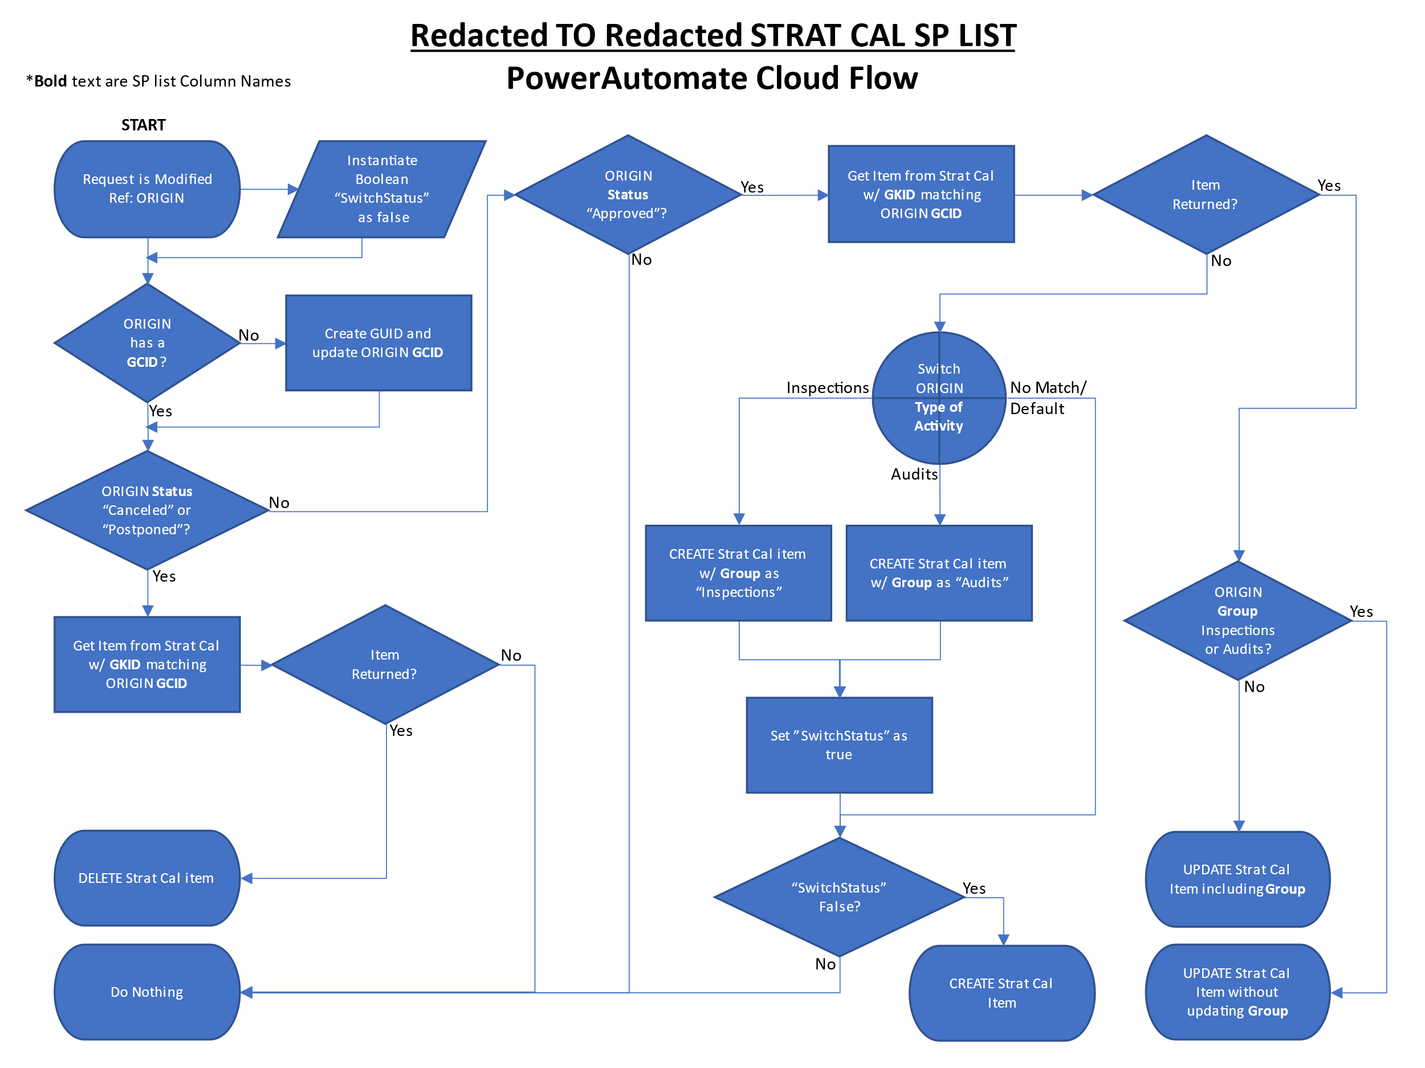

## *** Sync to ** ** Strat Cal SP List

This flow handles all items that the *** deems as both strategic and necessary to populate the calendar. It activates every time an item on the *** Sync SP list is modified. However, it will only process items whose **Push to Strat Cal** is checked. All items flowed to the ** ** Strat Cal SP list from the *** Sync will have their **Group** forced to “** **” to display as that category on the PowerApp.

### Step-by-Step

1. Item on the *** Sync SP list is modified
   1. **GKID** exists
      1. Go to 2
   2. **GKID** does not exist
      1. Create a GUID to populate the GKID column
2. **Push to Strat Cal** is not checked
   1. Do nothing
   2. END
3. **Push to Strat Cal** is checked
   1. Get all items from the ** ** Strat Cal SP list
      1. Filter the items using the **GKID** column matching the **GKID** of the *** Sync item that was modified to start this flow
         1. Only one item should return
   2. Filtered list returns an item
      1. UPDATE the item with “** **” as **Group**
      2. END
   3. No item returned
      1. CREATE the item with “** **” as **Group**
      2. END

### Flowchart

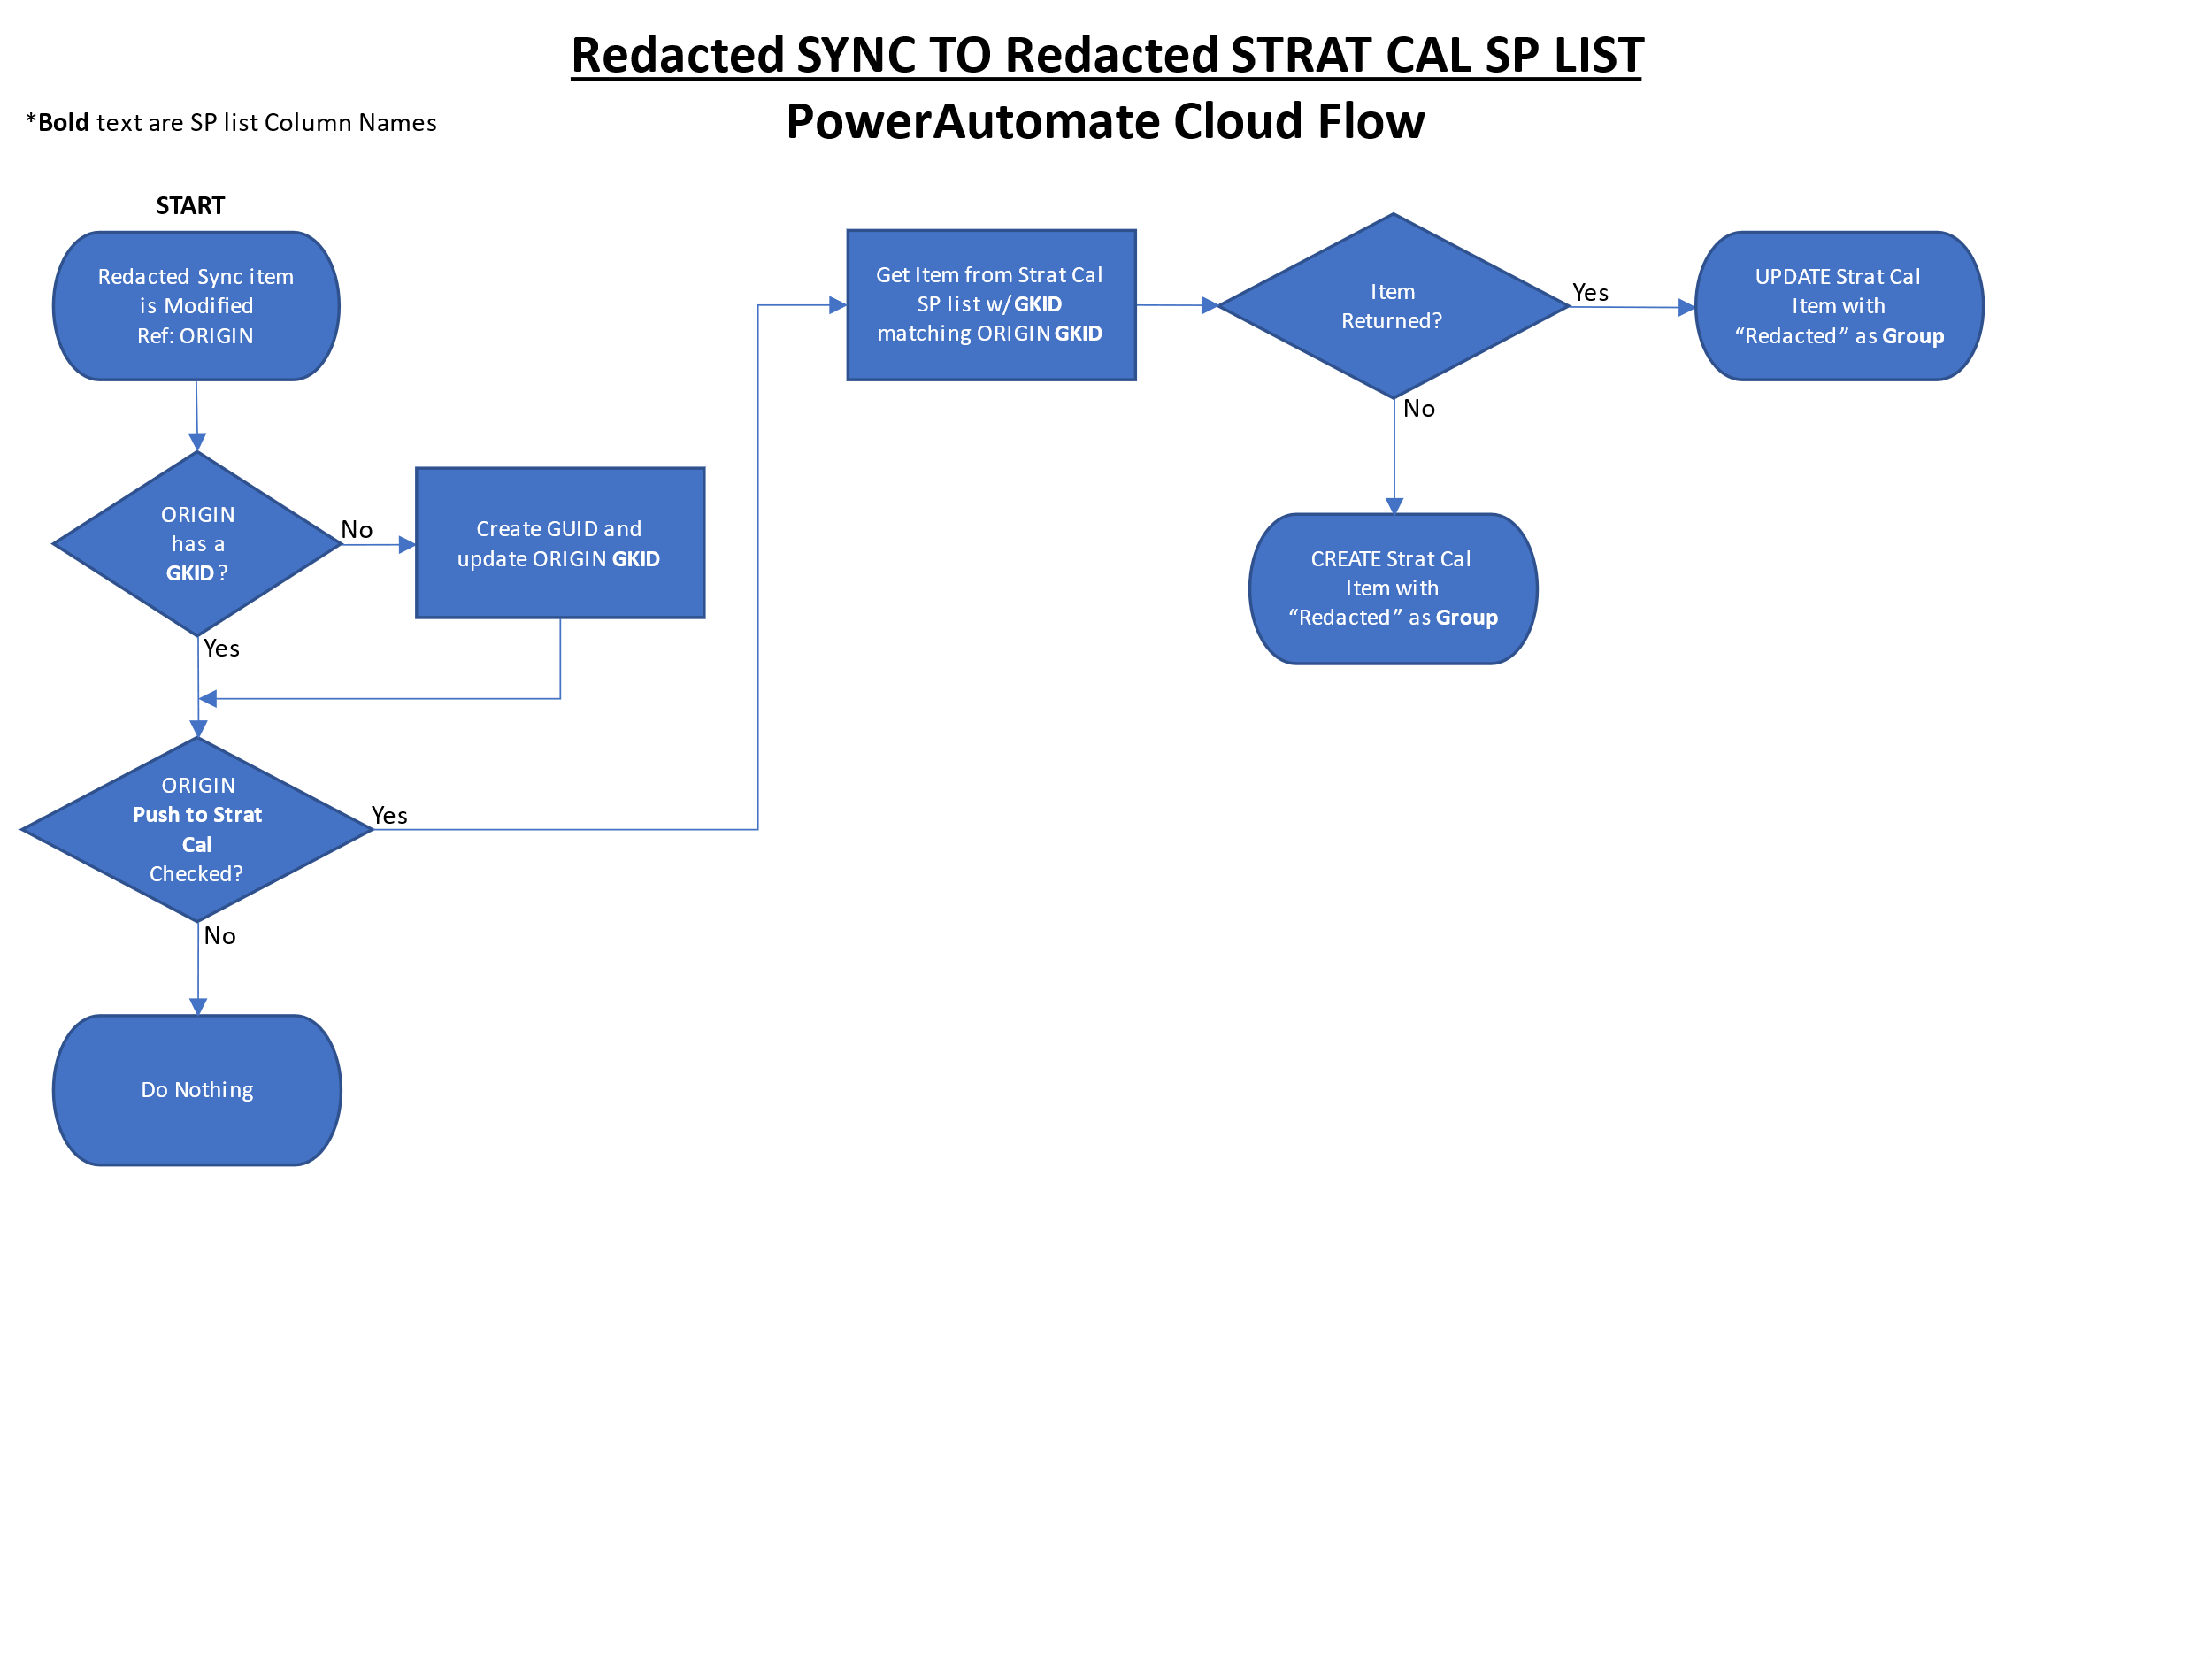

## ** **/*** Outlook to ** ** Strat Cal SP List

This flow copies items from the ** **/*** Outlook calendar to the ** ** Strat Cal SP list. It activates every time an item on the ** **/*** Outlook calendar is added, updated, or deleted. However, it will only process items whose **Title** contains the standalone term TDY. The ** **/CC Secretary is generally in charge of inviting the ** **/*** account to front office TDYs deemed worthy to display on the Strat Cal.

An oddity in dealing with Outlook events is that single-day all-day events come across starting on the day of the event at 0000 but ending on the **next** day at 0000. The PowerApp then interprets those items as two-day all-day events. Additionally, when these events are stored in SharePoint, the time zone for all- or multi-day events is incorrectly stored. This flow has a hack to convert time zones and end times when necessary. Note: The PowerApp is written to interpret zero-length items (i.e., starts 1 Dec 2022 at 0000 - ends at 1 Dec 2022 at 0000) as single-day all-day events. The hack in this flow exploits that “feature” when it “fixes” time elements.

### Step-by-Step

1. Item on the ** **/*** Outlook calendar is added, updated, or deleted
2. Instantiate **StartTime** and **EndTime** variables using **Start and End “Time with Time Zone”** properties
3. All day event?
   1. Yes
      1. Convert the time zone of the **Start Time** (*without* time zone) property
         1. Store in **StartTime** variable
      2. Convert the time zone of the **End Time** (*without* time zone) property
         1. Subtract one day to make the end time show on correct day on Strat Cal
            1. Store in **EndTime** Variable
   2. No
      1. Go to step 4
4. Boolean OR on **Subject**
   1. **Subject** equal to null?
   2. **Subject** contains TDY?
   3. Both No
      1. Do Nothing
      2. END
   4. Any Yes
      1. Switch Case on Outlook **Action Type**
         1. **added**
            1. CREATE event on Strat Cal SP List with **Group** as “**\*\* ** TDY**”
         2. **updated or deleted**
            1. Get matching item from Strat Cal SP List
            2. UPDATE or DELETE (based on **Action Type**) Strat Cal item

Flowchart on next page.

### Flowchart

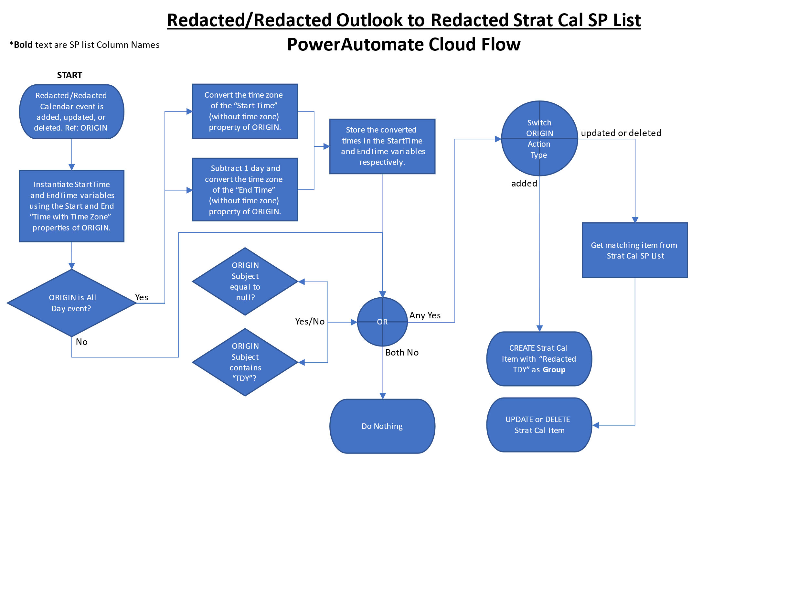

## ** Google to ** ** Strat Cal SP List

This flow copies items from the ** Google Calendar to the ** ** Strat Cal SP list. It activates every time an item on the ** Google calendar is added, updated, or deleted. However, it will only process items whose **Title** begins with CAT1, CAT2, CAT3, CAT4, CAT 1, CAT 2, CAT 3, or CAT 4. ** controls their Google calendar items and have agreed to work with the *** to ensure items that need the ** **/CC’s attention will meet this naming convention. Additionally, as personnel rotate in the ***, they will need to gain access to the ** Google calendar to establish an external data connection to Google and update the PowerAutomate flow. This flow **will not** work if the ** Google data connection is not intact.

An oddity in dealing with Google events is that single-day all-day events come across with no time element. Because of this, when they are stored in SharePoint, the time zone is modified causing the event to appear as if starting the day before. The PowerApp then interprets those items as two-day all-day events. This flow has a hack to add a time element while ensuring time zone conversions do not cause issues. The PowerApp is written to interpret zero-length items (i.e., starts 1 Dec 2022 at 0000 - ends at 1 Dec 2022 at 0000) as single-day all-day events. The hack in this flow exploits that “feature” when it inserts time elements to the start/end dates.

### Step-by-Step

1. Item on the ** Google calendar is Added, Updated, or Deleted
2. **Title** does not begin with any (case sensitive):
   1. CAT1, CAT2, CAT3, CAT4, CAT 1, CAT 2, CAT 3, or CAT 4
      1. Do nothing
      2. END
3. **Title** of the event begins with any (case sensitive):
   1. CAT1, CAT2, CAT3, CAT4, CAT 1, CAT 2, CAT 3, or CAT 4
4. Time element is not included with **Start/End Date**
   1. Create 0000hr timestamp StartTimeHacked and EndTimeHacked for **Start/End Date**
   2. Go to step 5.1
5. Time element is included **Start/End Date**
   1. Get all items from the ** ** Strat Cal SP list
      1. Filter the items using the **GKID** column matching the **ID** of the ** Google item that was modified to start this flow
         1. Only one item should return
   2. Filtered list returns an item
      1. Switch case on ** Google **Action Type**
         1. **Action Type** is “deleted”

Delete item from ** ** Strat Cal SP list

END

* + - 1. Default/No match
         1. StartTimeHacked exists

UPDATE item on ** ** Strat Cal SP list with StartTimeHacked and EndTimeHacked as **Start/End Dates**

END

* + - * 1. StartTimeHacked does not exist

UPDATE item on ** ** Strat Cal SP list

END

* 1. No item returned
     1. StartTimeHacked exists
        1. CREATE item on ** ** Strat Cal SP list with StartTimeHacked and EndTimeHacked as **Start/End Dates**
        2. END
     2. StartTimeHacked does not exist
        1. CREATE item on ** ** Strat Cal SP list
        2. END

### Flowchart

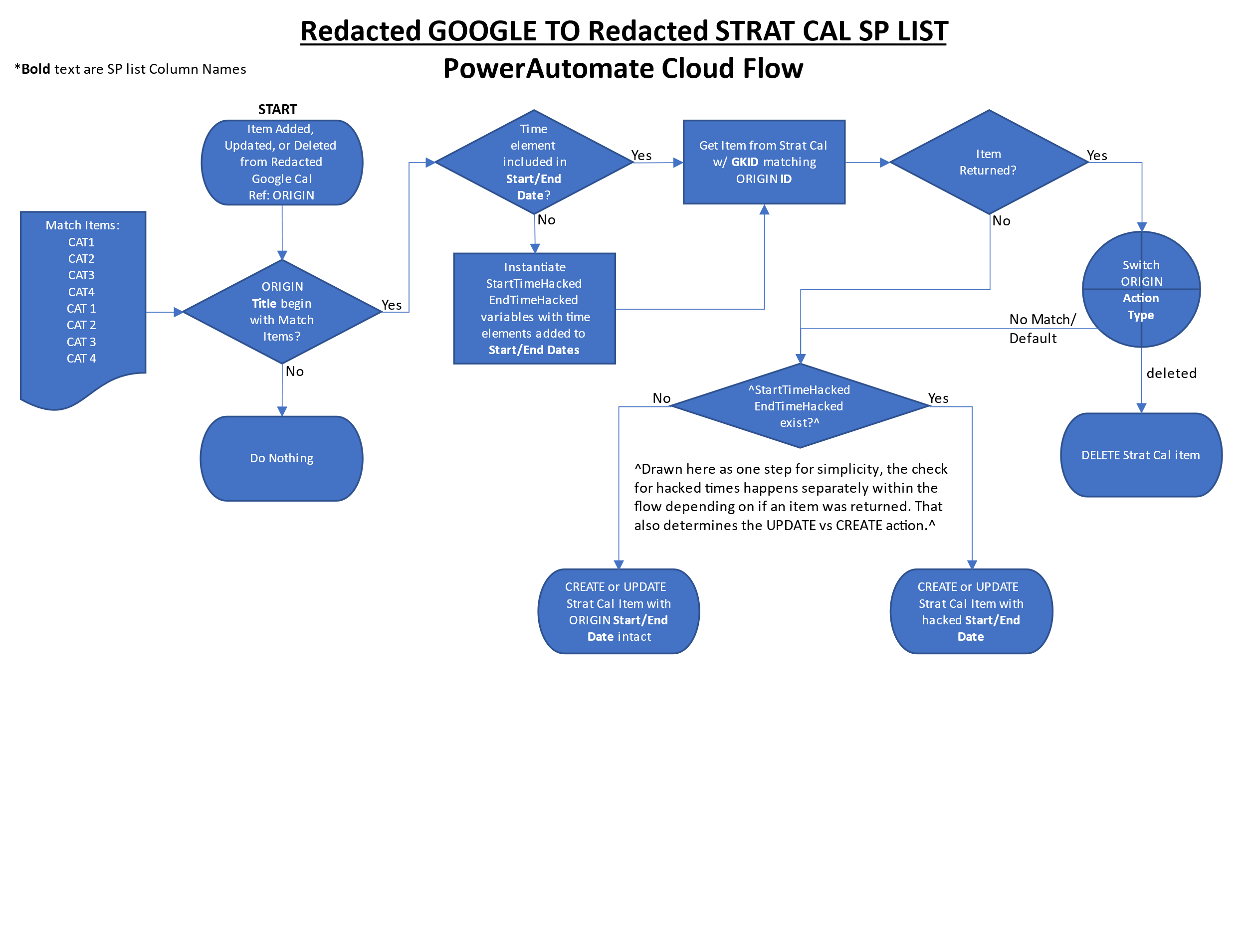

## ***** to *** Event Tracker

This flow activates every time an item on the ***** is modified, but only processes items that are deemed strategic with the **Strategic (** ** Use Only)** checkbox checked. Only *** personnel and the ** **/CC should check the **Strategic (** ** Use Only)** checkbox.

### Step-by-Step

1. Item on the ***** SP list is modified
2. **Status** is not “Approved”
   1. Do nothing
   2. END
3. **Status** is “Approved”
   1. **Strategic (** ** Use Only)** is not checked
      1. Do nothing
      2. END
   2. **Strategic (** ** Use Only)** is checked
      1. Get all items from the *** Event Tracker SP list
      2. Filter the items using the **GKID** column matching the **GCID** of the ***** item that was modified to start this flow
         1. Only one item should return
      3. Filtered list returns an item
         1. UPDATE *** Event Tracker item
         2. END
      4. No item returned
         1. CREATE *** Event Tracker item
         2. END

### Flowchart

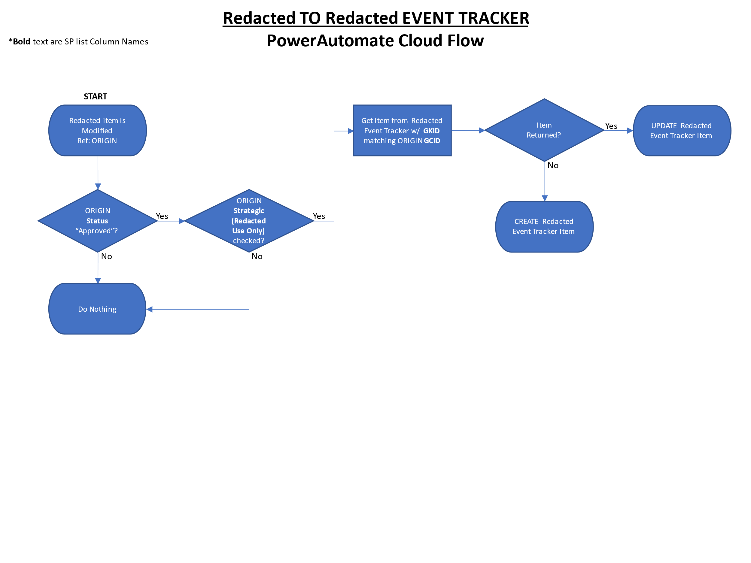

## *** Event Tracker to *** Sync

This flow activates every time an item on the *** Event Tracker is created or modified. To successfully copy projo information from the *** Event Tracker to the *** Sync, there are a lot of extra steps involved. The projo column in both lists are the “Person” type that fills with enterprise contact info. SharePoint cannot directly handle the data (called “claims”) that the flow extracts from the column. So, it must be formatted in a way that the *** Sync column can read and resolve the “Person” info after the flow has finished.

### Step-by-Step

1. Item on the *** Event Tracker is created or modified
2. Create data array to hold projo claims
   1. Gather and store projo claims in the array if they exist
   2. Reformat the claims into SP readable/resolvable format
3. Get all items from the *** Sync SP list
   1. Filter the items using the **GKID** column matching the **ID** of the ***** item that was modified to start this flow
      1. Only one item should return
   2. Filtered list returns an item
      1. Projo array empty
         1. UPDATE *** Sync item without projo info
         2. END
      2. Projo array contains data
         1. UPDATE *** Sync item with projo info
         2. END
   3. No item returned
      1. Projo array empty
         1. CREATE *** Sync item without projo info
         2. END
      2. Projo array contains data
         1. CREATE *** Sync item with projo info
         2. END

### Flowchart

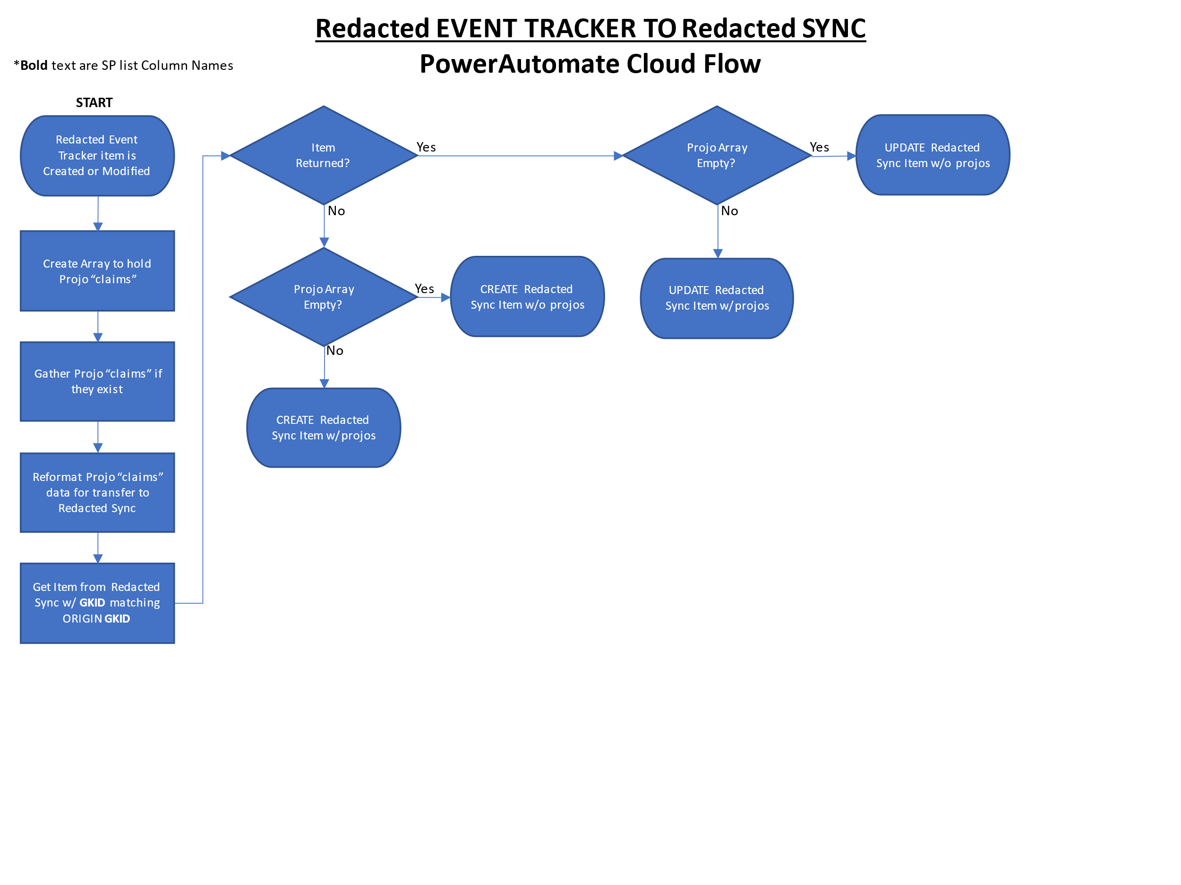

## Email and Create Folder – New Event

This flow is not directly connected to any strat cal workings, but is important for *** use. This flow activates only when a *** Event Tracker item is created. It does not matter if the *** Event Tracker item was created manually or by the “***** to *** Event Tracker” flow.

This flow’s first task is to create a SP folder on the *** SP site for the projos to use for event planning. The folder name is derived from the **Event Subject** column of the *** Event Tracker. Keep in mind that the *** Event Tracker’s **Event Subject** column is often derived from the originating SP list item. As such, there is very simple data verification/sanitization/protection to ensure illegal characters (< > : “ / \ | ? *) do not make it into the folder name. *The data verification/sanitization/protection does not work well.* It is up to *** personnel to detect illegal characters in event **Titles,** especially coming from the *****. Ensure you modify the title on the ***** to remove any illegal characters if you are planning to check the **Strategic (** ** Use Only)** checkbox. Before creating the folder, the flow will check if a folder with the same name already exists. This is a good thing, as previous year’s event data will immediately be available to this year’s projos (assuming everything works).

The next task is to create a shareable link of the folder that was created, or the one that already exists. There is a loop in the flow that checks for existence of the new folder before trying to create the link. It will fail if the folder wasn’t created for some reason (i.e., a special character in the title). Once the shareable link is created, the flow stores the link the *** Event Tracker item’s **Event Folder (*** Use Only)** column.

The final task is to generate an email with a link to the *** Event Tracker item and a link to the SP folder and send the email to the projos listed in the **Project Officers** column. The email will be from the *** org inbox. Unless the item that activated this flow was created manually with projo names already in the **Project Officers** column, the email will not generate/send from this flow because this flow only runs when an item is created. If the item is created from the “***** to *** Event Tracker”, no projo info will be present. There is another flow, that will not be detailed, that handles projo updates and resends of the email.

### Step-by-Step

1. Item on the *** Event Tracker is created
2. List folders on *** SP site
   1. Create data array to filter folder list based on the **Event Subject** column
3. The array is empty
   1. Create folder with name based on the **Event Subject** column
      1. Loop checking for folder until folder exists
      2. Go to 5.
4. The array contains data
   1. Get information on the folder that was found
5. Create shareable link
   1. UPDATE *** Event Tracker item **SharePoint Folder (*** Use Only)** column
6. Generate/send email to projos
7. END

### Flowchart

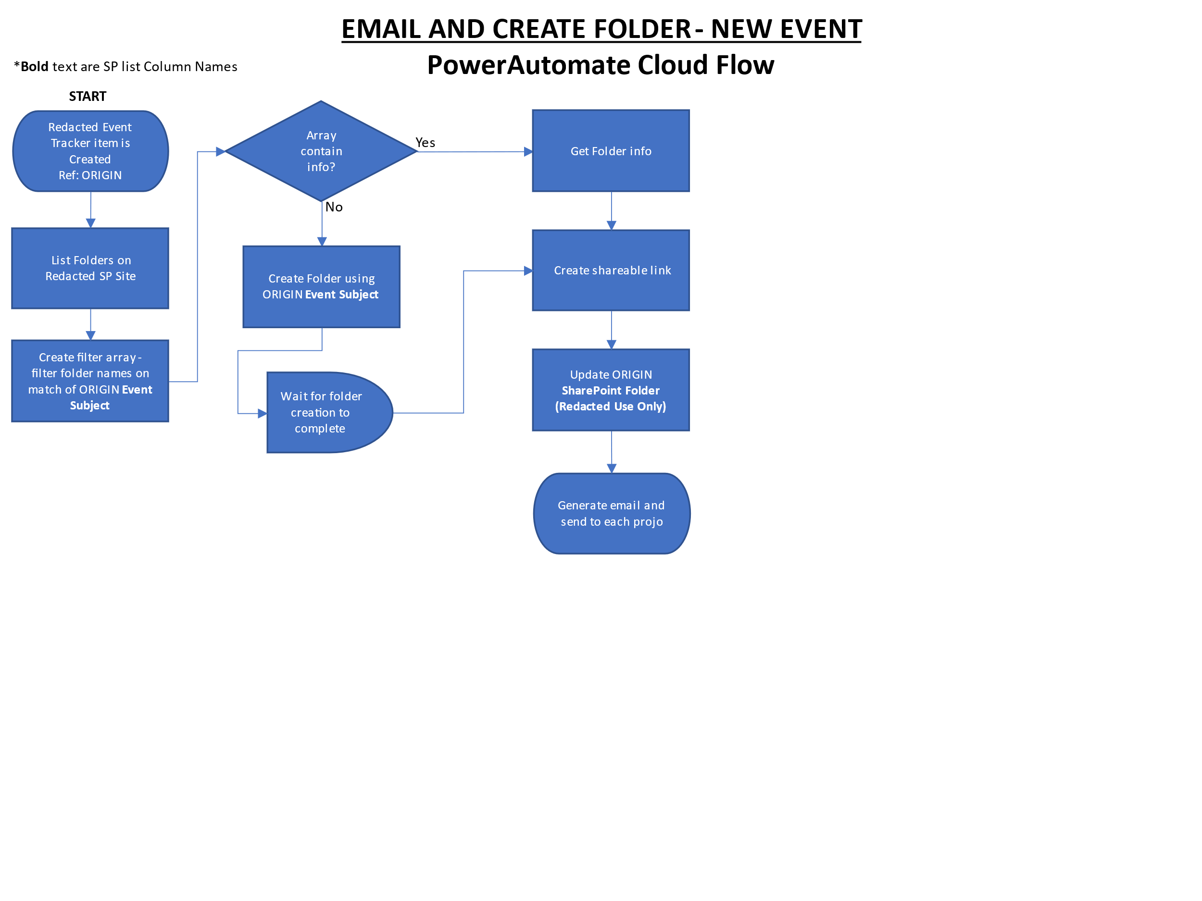

# The ** ** Strat Cal PowerApp User Overview

The PowerApp was created from the Outlook Calendar template found in the enterprise Power Platform template collection. The template was modified to read from a SP data source instead of Outlook. Some of the template’s original code still exists, but by and large, the rest of the template has been heavily modified to meet the ** **’s specific needs. Additionally, portability was not in mind for a lot of the development process. So, copying the app for other units is not exactly easy (though also not hard).

Finally, keep in mind that MS continues to develop and add features to the Power Platform, including PowerApps. So, some of the workarounds for getting basic programmatic operation may no longer be necessary. However, there are no plans to overhaul the PowerApp as MS adds features.

## Main Calendar Screen

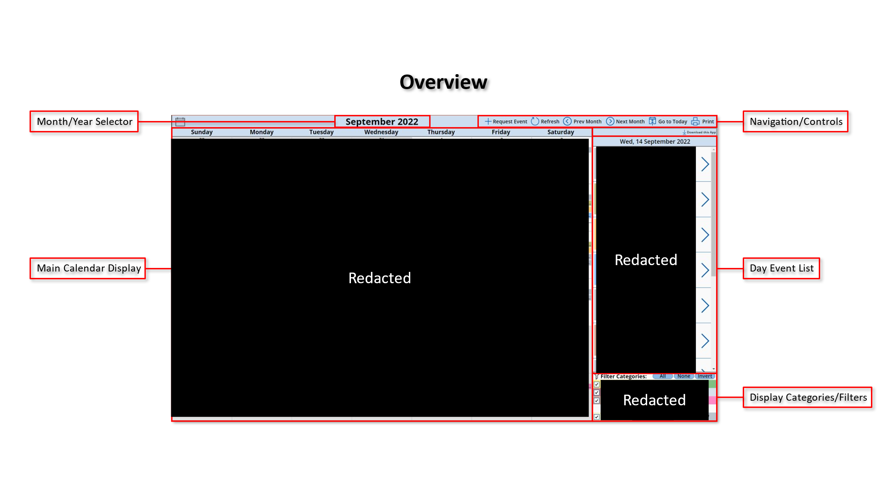

### Main Calendar Display

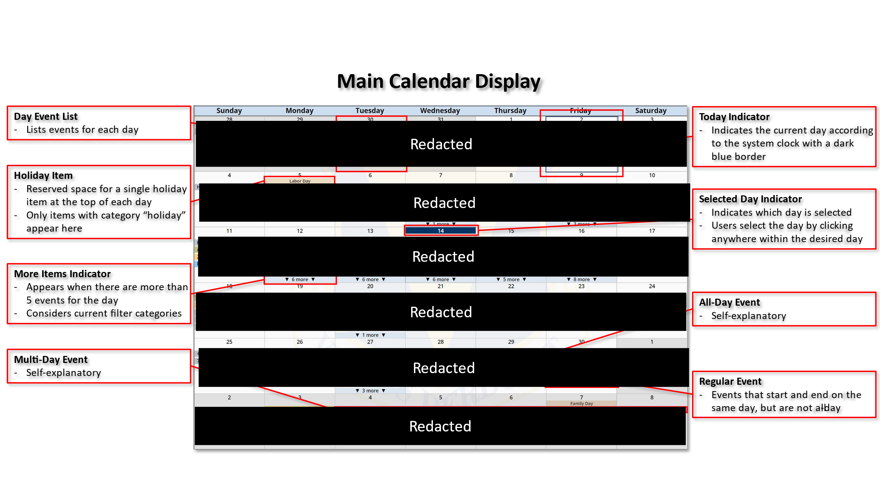

### Month/Year Selector

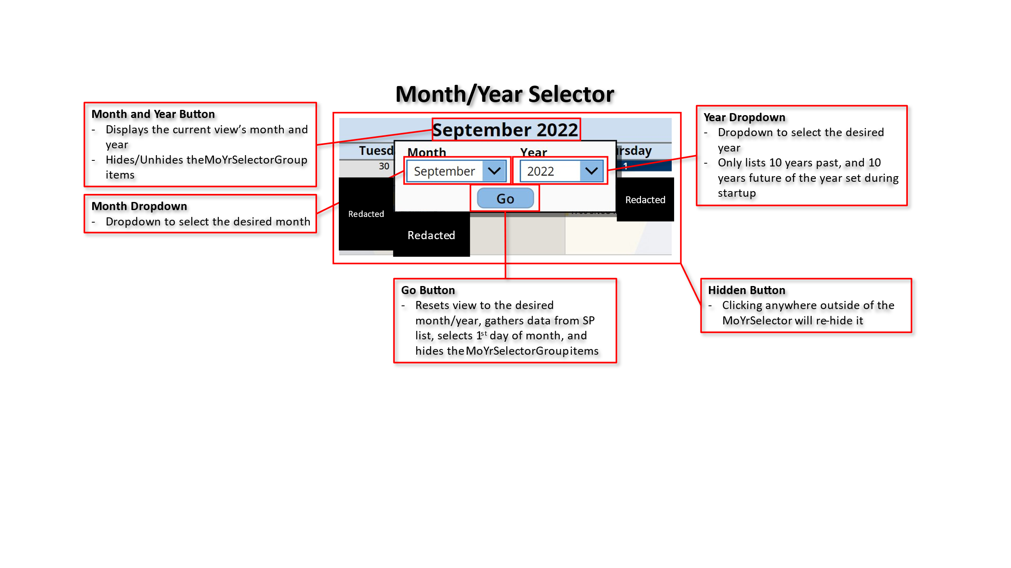

### Navigation/Controls

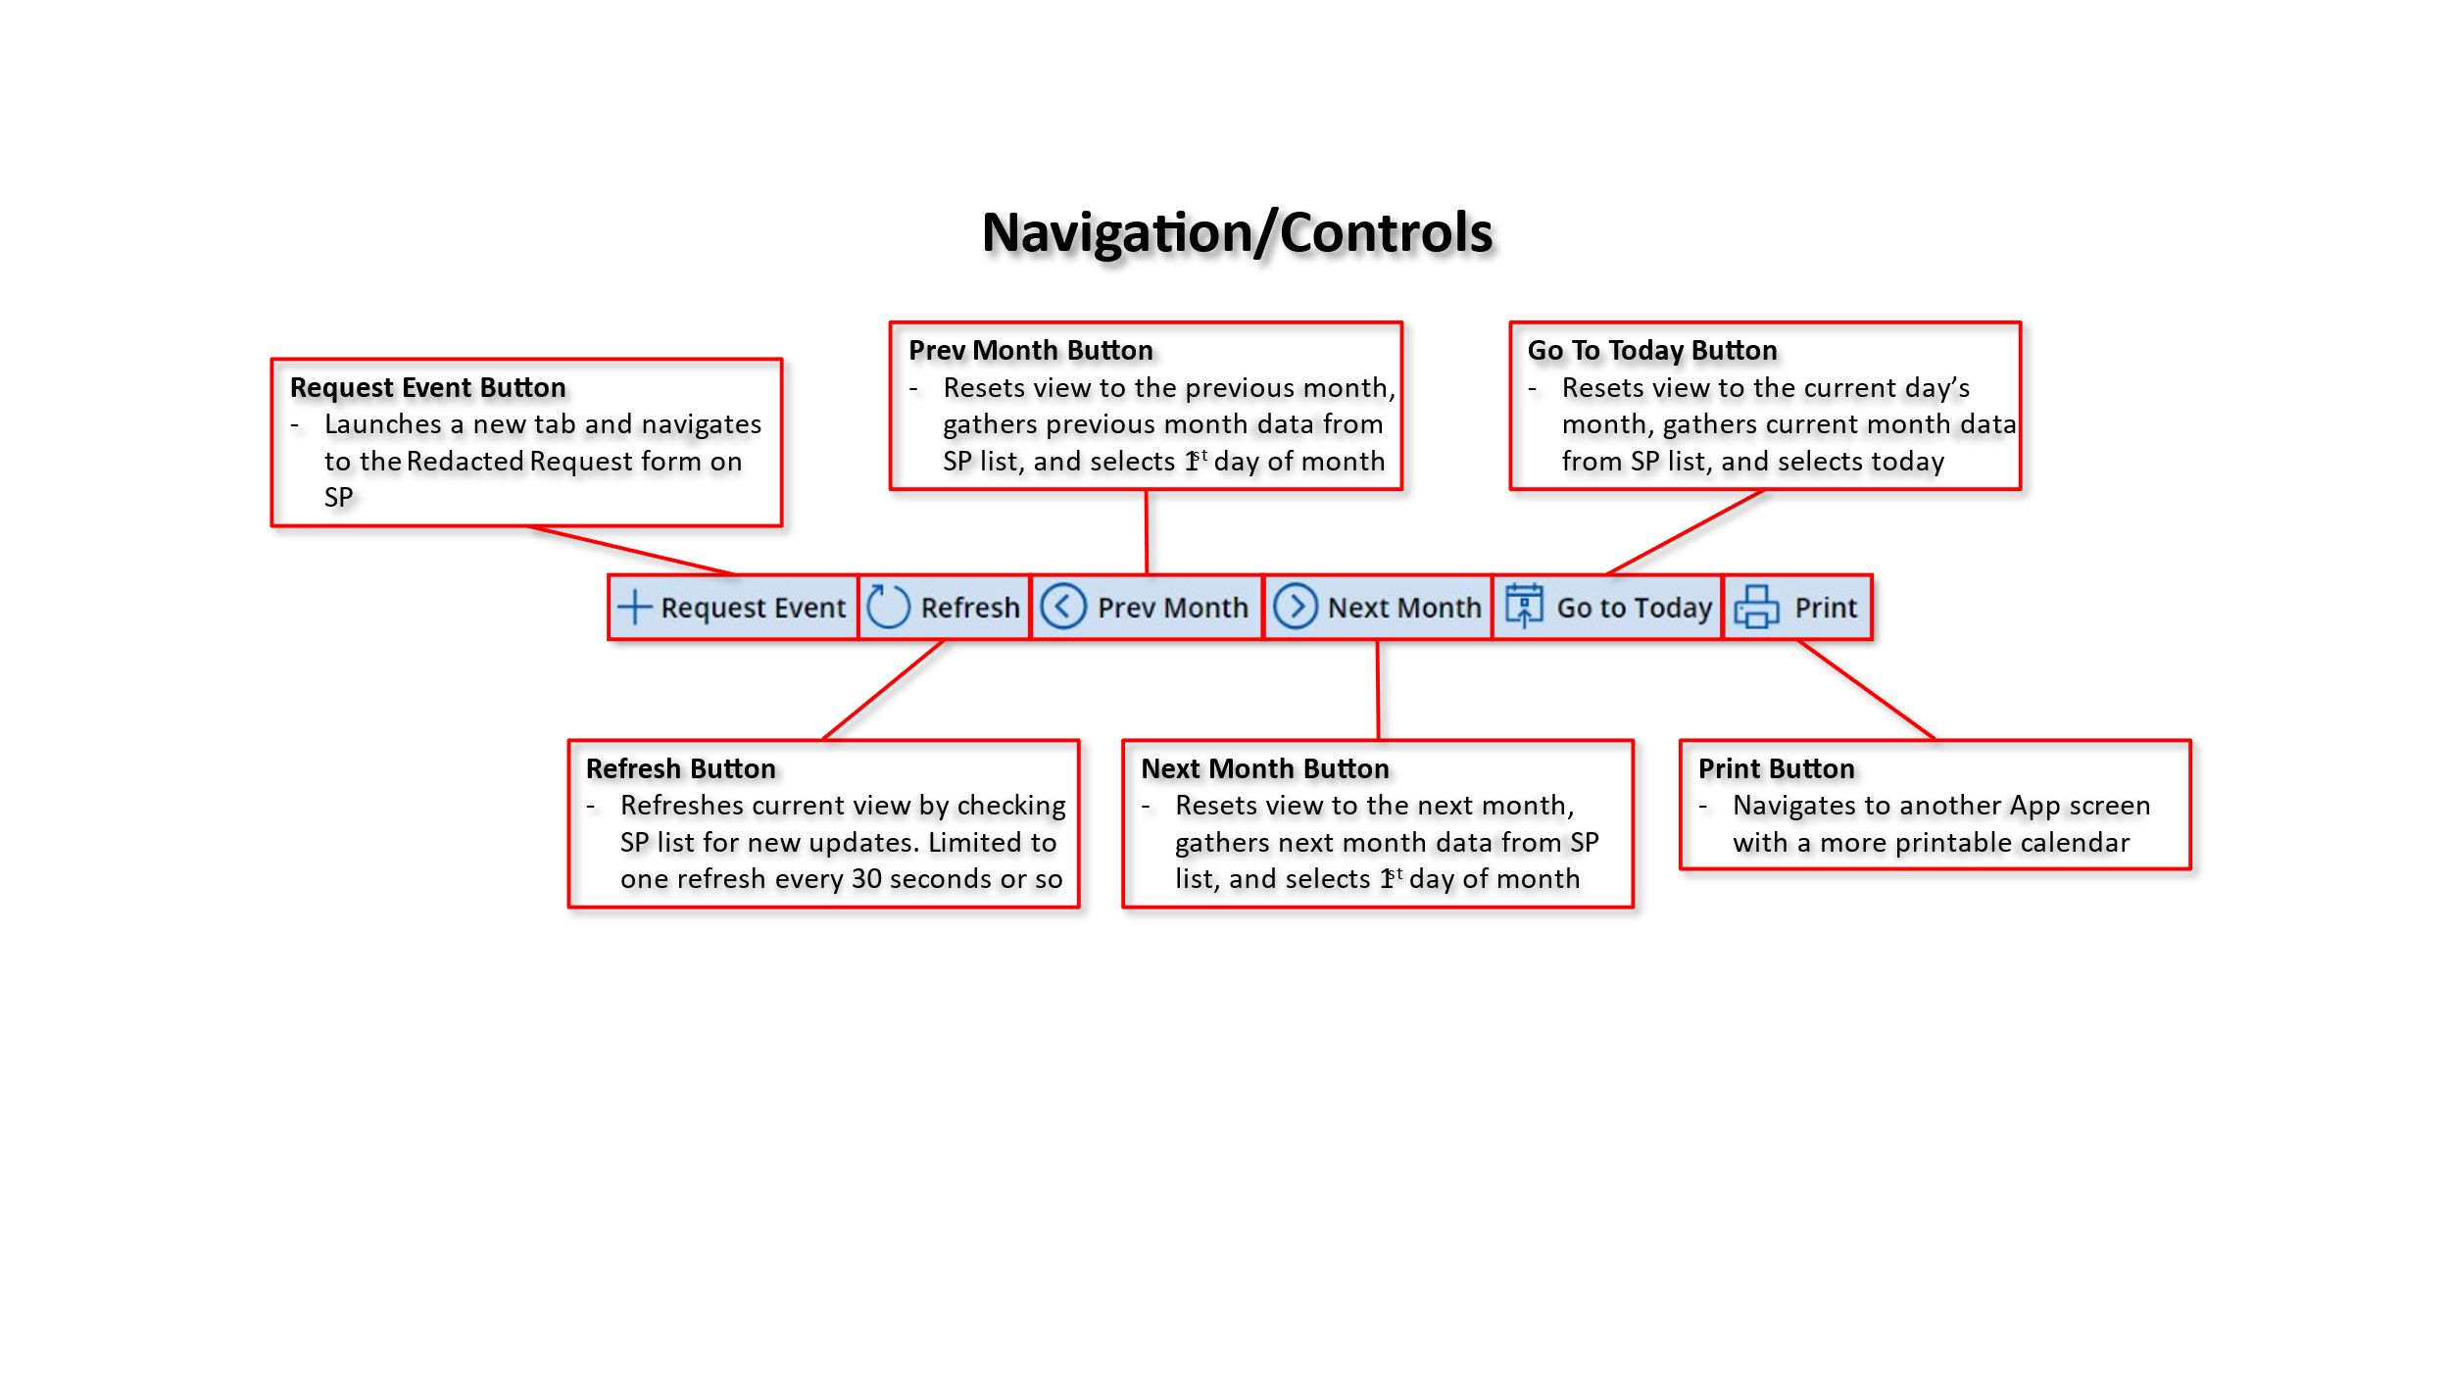

### Day Event List

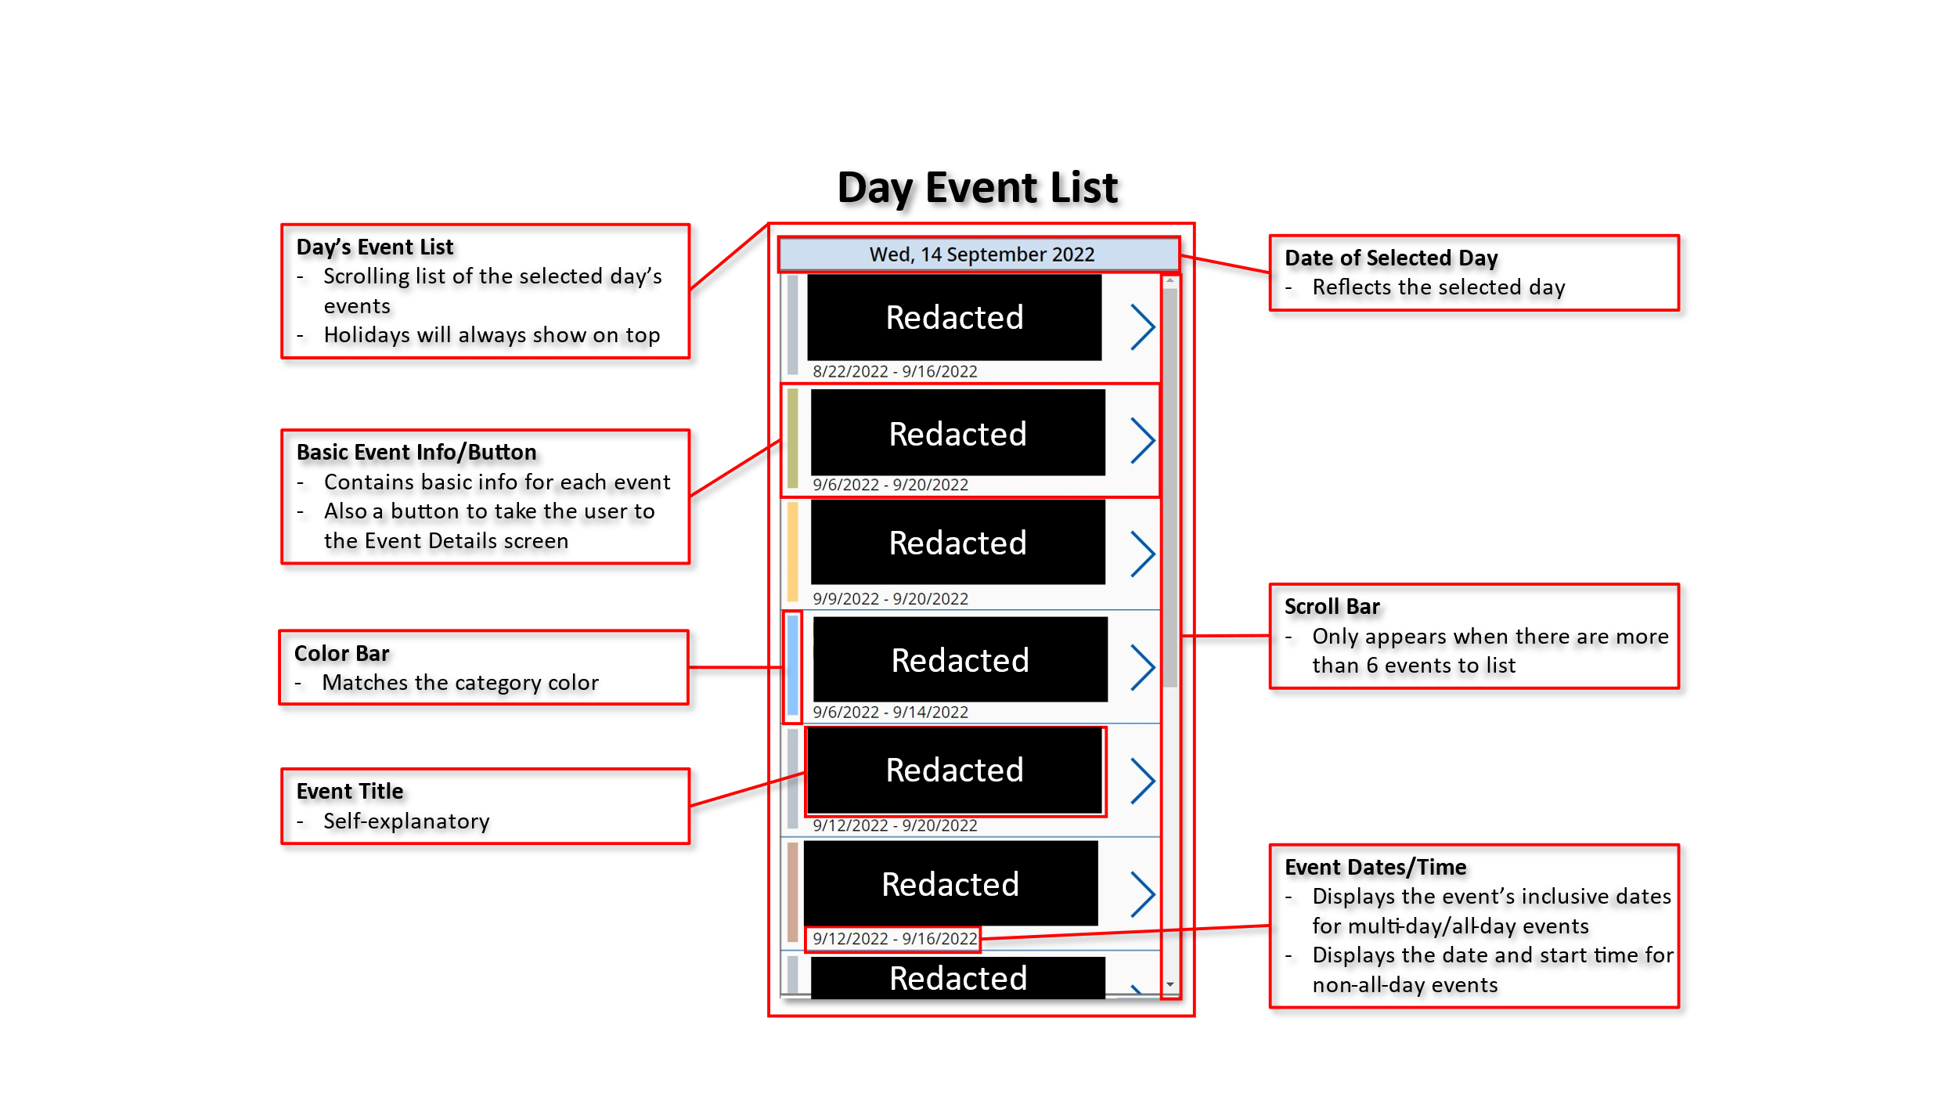

### Display Categories/Filters

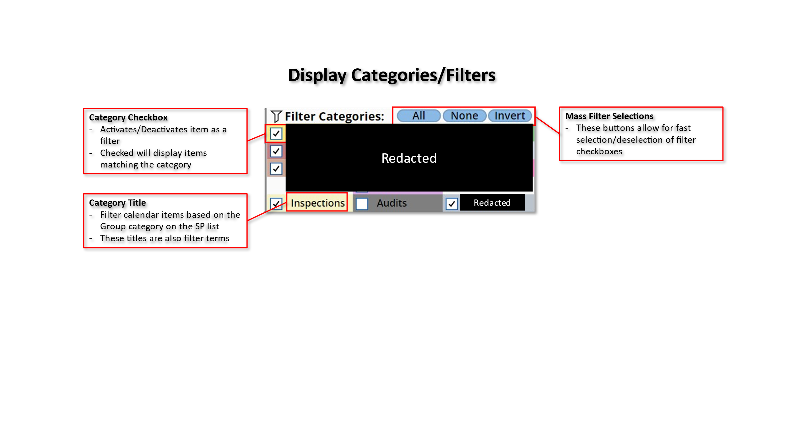

### Filter Selection Example

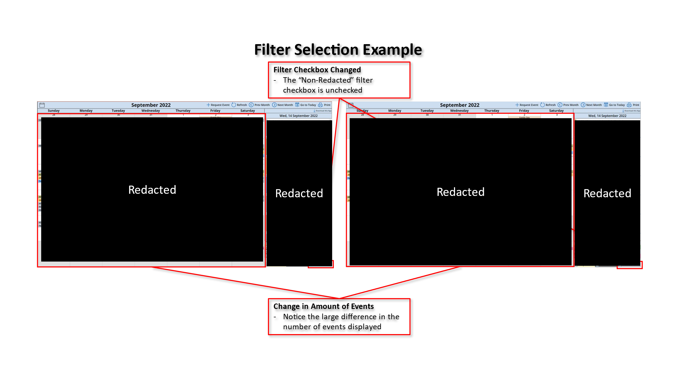

### Event Details Screen

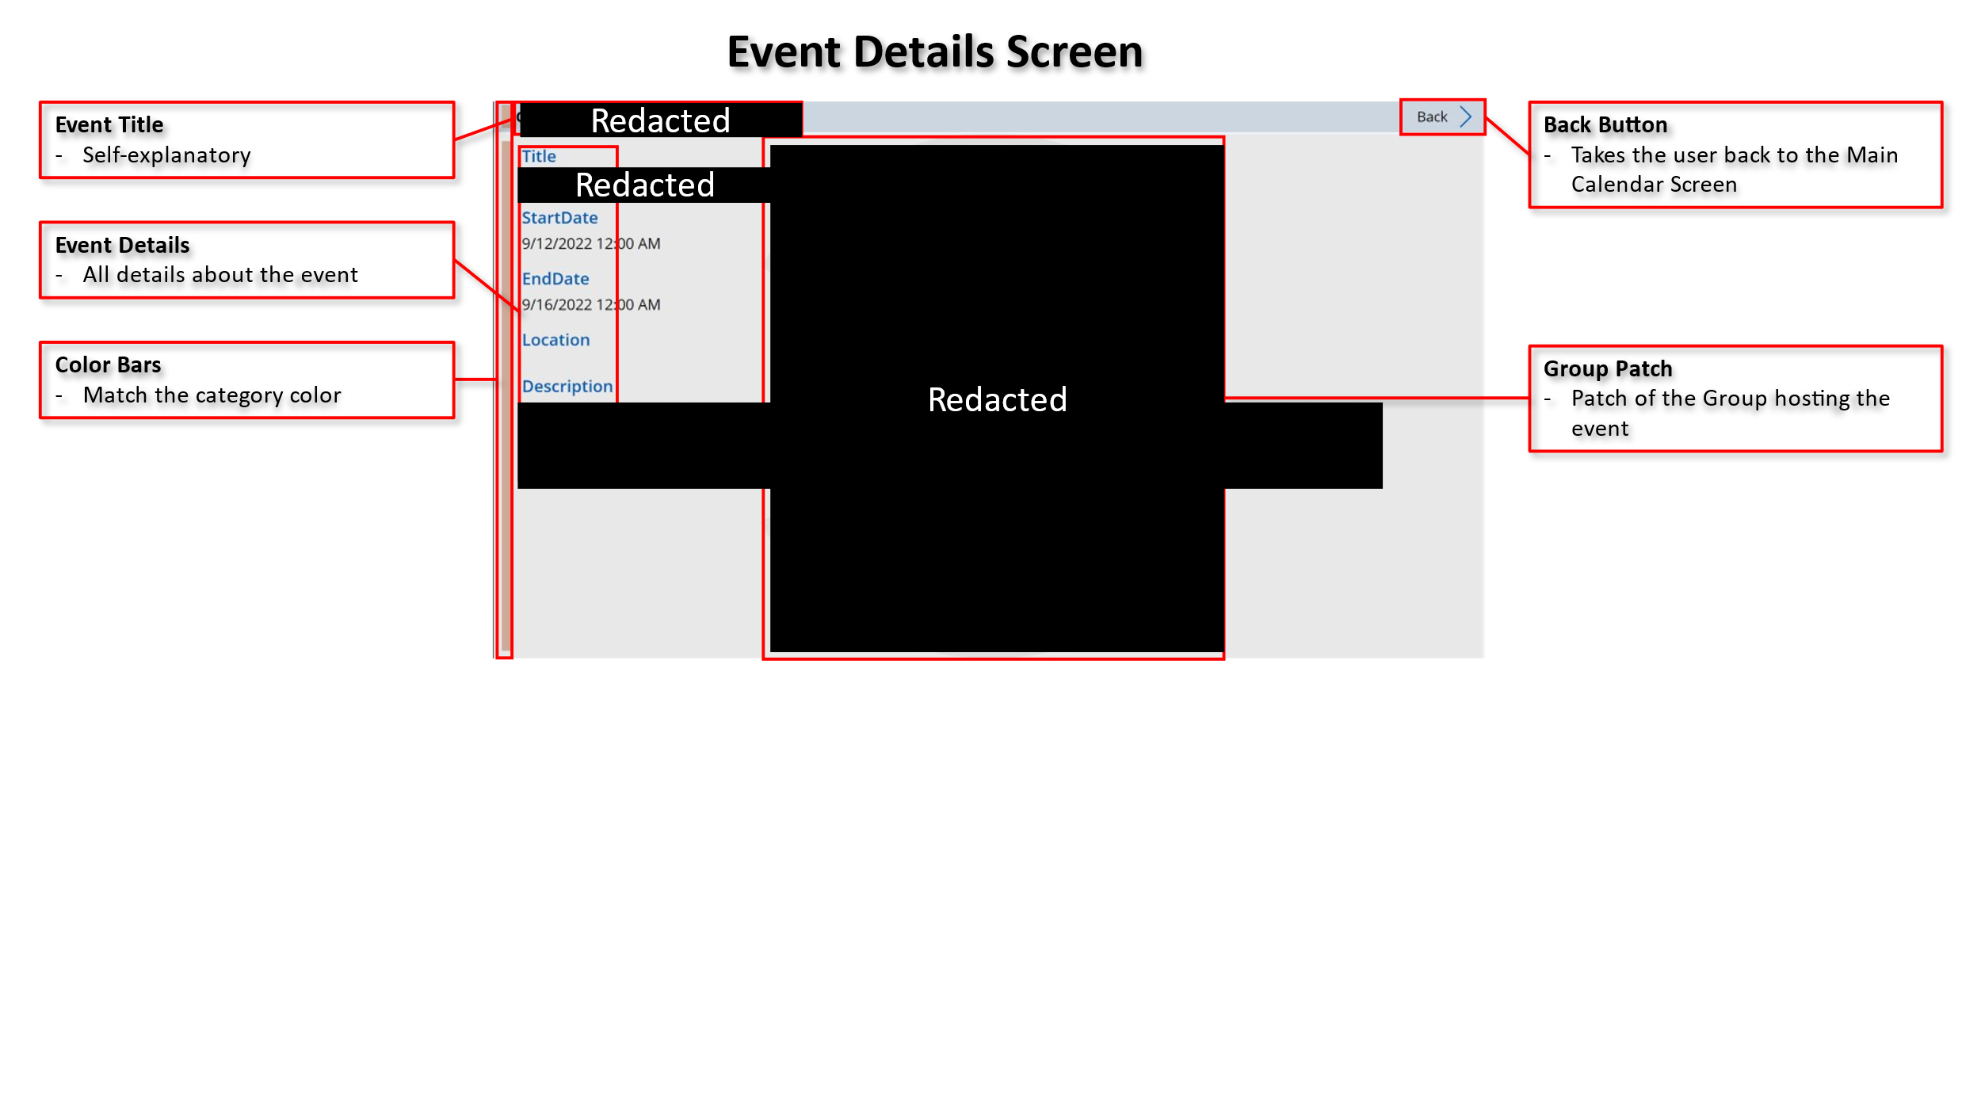

## Printable Calendar Screen

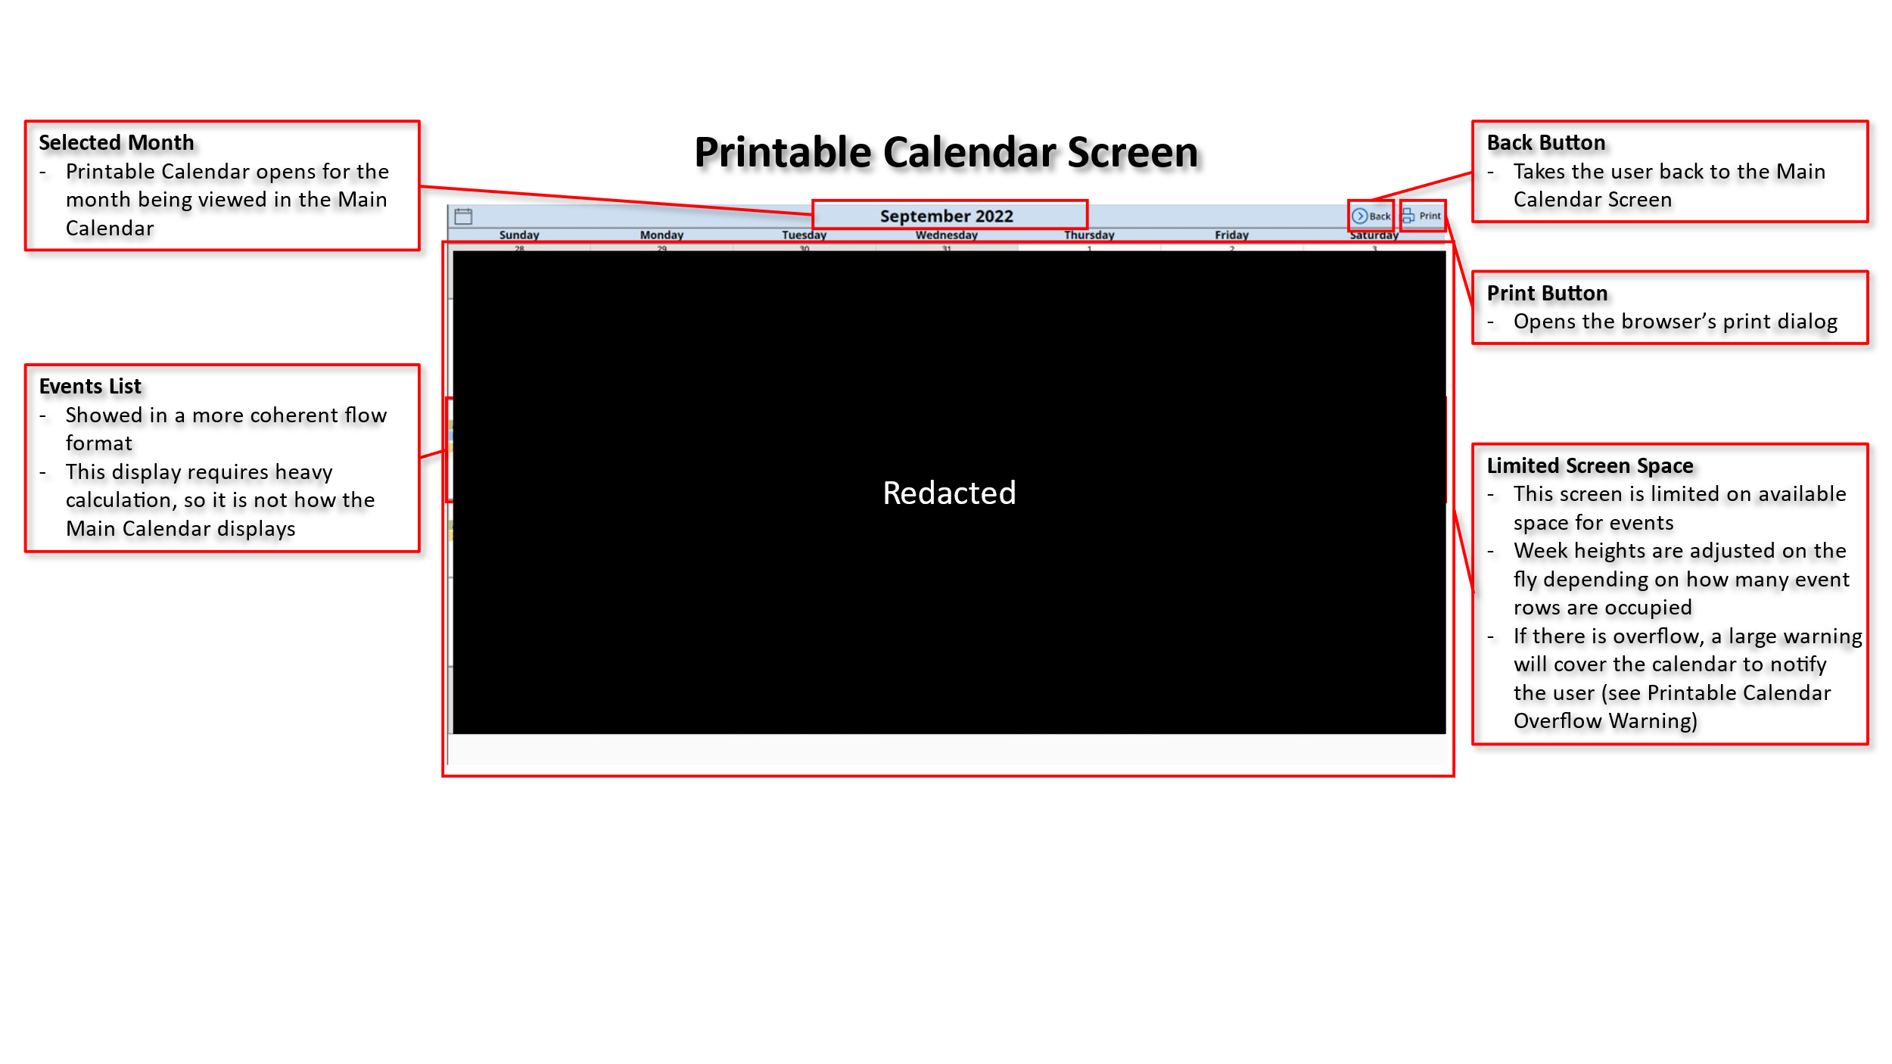

### Overflowed Printable Calendar Screen Example

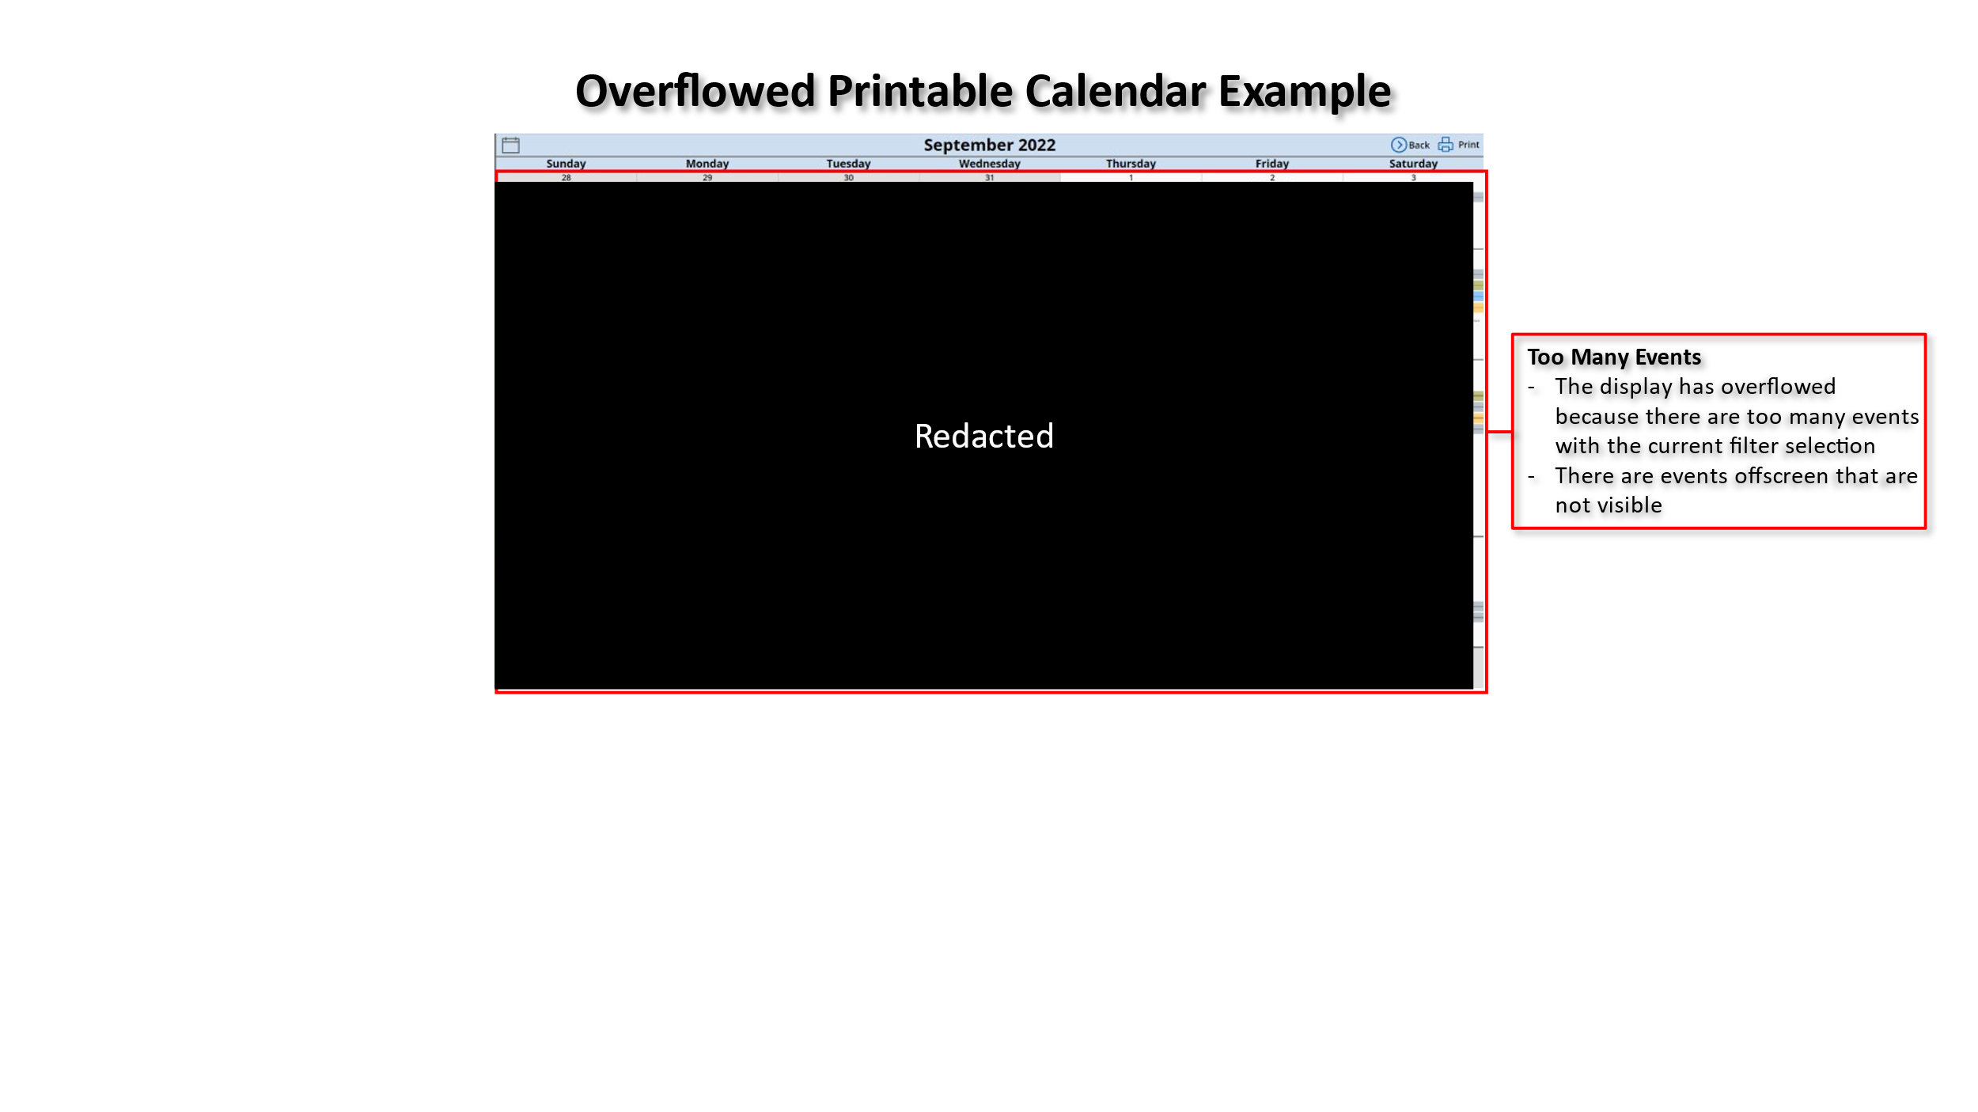

### Printable Calendar Overflow Warning

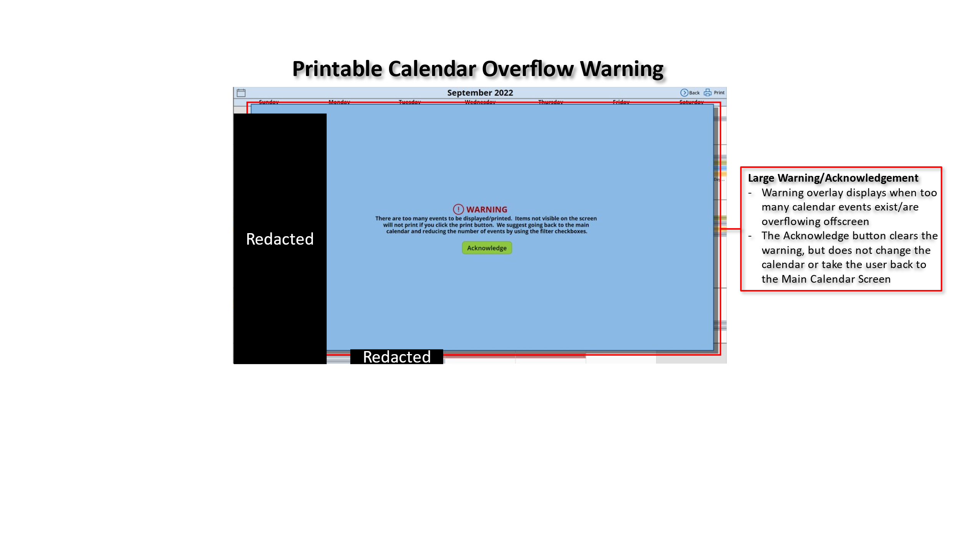

# ** ** Strat Cal PowerApp Developer Overview

This is an overview of the app for developers. It is only basic information and assumes that you know, or can figure out, your way around the Power Platform and PowerApps interface.

## Data Elements in the App

The data connection used for the PowerApp is a SP connection based on the owner. It will need to be changed every time there is changeover of new *** personnel for maintenance of the app.

The data collections are created via code and calculation, or hard-coded. They are used in multiple locations throughout the app.

* **CalendarItems** and **CalendarItemsPrint:**  local storage of SP event data
* **colors**: used to define filter/category colors and images in one place rather than many
* **MaxRows, DailyRowCounts, AvailableSlots, TakenSlots, DailyItemsReturned, DailyItems,** and **EventOrderCalcVariables**: used for ordering and spacing events on the Calendar Print Screen
* **checkVals:** stores filter/category checkbox values including the initial default selection

## Global Variables in the App

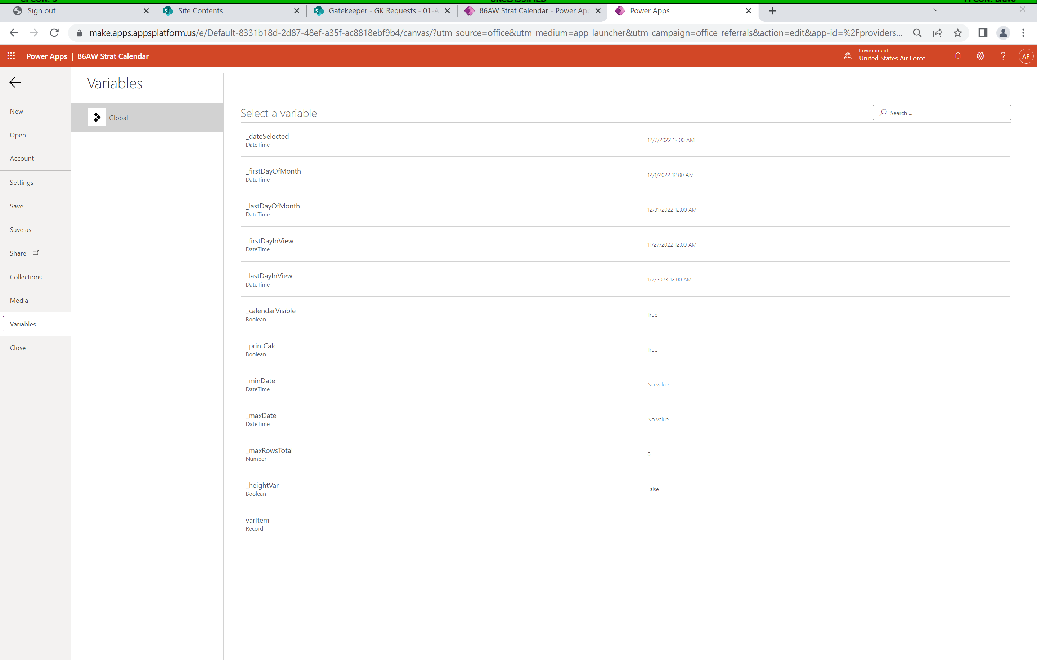

All variables in the app are global.

* **_dateSelected**
  + Defines the day that the user selects. It is set to Today on start and upon clicking the “Go to Today” button. It is set to the first of the month when the Next or Prev Month buttons are clicked. It is otherwise set to the day the user clicks.
* **_firstDayOfMonth**
  + Defines the first day of the month for controlling where the month in view starts and color theming. This variable is calculated against the Today() function.
* **_lastDayOfMonth**
  + Defines the last day of the month for controling where the month in view ends and color theming. This variable is calculated against _firstDayOfMonth.
* **_firstDayInView**
  + Defines the first day in the view since the calendar does not start on the first day of the month. This variable is also used to check for events with inclusive dates outside of the month, but inside the view. This variable is calculated against _firstDayOfMonth.
* **_lastDayInView**
  + Defines the last day in the view and is used to check for events with inclusive dates outside of the month, but inside the view. This variable is calculated against _firstDayInView.
* **_calendarVisible**
  + Defines if MainCalendar is visible or not. It keeps the calendar invisible until OnStart is complete.
* **_printCalc**
  + A Boolean helper variable to let MainCalendar know if the printable calendar’s calculation is complete for the current view or not.
* **_minDate & _maxDate**
  + Prevent duplication of events during navigation to other months.
* **_maxRowsTotal**
  + Counts the number of rows used on the PrintCalendar screen.
* **_heightVar**
  + A Boolean helper variable to warn users if there are too many events to print.
* **varItem**
  + Defined when the user clicks on a specific event in the Day Event List on the right side of MainCalendar. varItem is passed to the CalendarItemDetails screen for displaying desired event info.

## Media Elements in the App

The only media elements in the app are the ** **, Group, and ** patches. They display in the background of the Main Calendar screen and the CalendarItemDetails screen. Media is referenced in the app by the filename without the extension.

Notice that there is a 200MB limit for media.

## Screens in the App

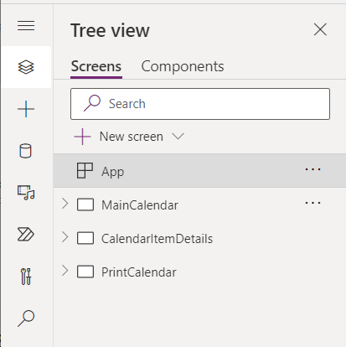There are three screens in the app.

* **MainCalendar:**  The main screen displayed at startup containing the calendar, event lists, navigation, and filters/categories
* **CalendarItemDetails**: This screen is called when the user clicks on an event item in the right-side Day Event List
* **PrintCalendar**: This is the printable calendar that displays when the user clicks the “Print” button at the top right of the MainCalendar screen

# ** ** Strat Cal PowerApp Code Elements

This section explains as much technical detail as possible and/or I understand (some code elements were written by ***** ***** “*****” *****, and he is much more intelligent than I am when it comes to coding). It is meant to augment the comments already in the codebase.

Some important, but not vital, elements are not covered in-depth here. As a rule, you should know that some controls in the PowerApp are purposely not visible to the user and should remain that way. Enabling visibility on these controls while developing can be extremely useful for troubleshooting, but they should be re-hidden when the developer is done. Additionally, when development of this PowerApp started, some basic programmatic elements were missing from the PowerApps platform altogether. Examples include local variable storage, local variable calls, and functions. You will see that a lot of hidden controls are simply variable storage since it didn’t exist at the time of development. As of this writing, you can now store formulas at the app level as if they were functions (think of SQL stored procedures). So, some the repetitive code elements below could now be stored as formulas at the app level to clean up and remove repetition. But, as was said earlier, there are no plans to keep up with MS and their changes so long as the app is functional.

This manual is going to assume that you can figure out Power Platform/PowerApps details from freely available online information.

https://learn.microsoft.com/en-us/power-apps/powerapps-overview

## App-Level



### App.OnStart

The App.OnStart is a special location for code that is only run once when the app starts. While in the PowerApps editor, you can rerun OnStart by right clicking on “App” in the tree view.

The code below sets the calendar’s initial view by setting the **_dateSelected** to today, then establishing the **_firstDayOfMonth**. Additional variables are calculated against **_firstDayOfMonth** to establish where and how days are shown and shaded. After the layout is established, the **_calendarVisible** Boolean is set to true, making the MainCalendar screen visible. Lastly, four collections are created for setting default for the filter checkboxes (**checkVals**), storing theming information (**colors**), and making month and year lists for the **YrMoSelector** dropdowns (**colYears** and **colMonths**).

**checkVals** column data is defined below:

- **CheckBox**: the OnCheck and OnUncheck properties of each checkbox refers to this column

- **Name**: is a verbatim match to the Text property of each checkbox and the GroupCatgory column in the SP list, also a search term

- **Value**: determinator for each checkbox’s status (checked or unchecked)

**colors** column data is defined below:

- **GroupCategory**: is a verbatim match to the GroupCategory column in the SP list, also a search term

- **Color**: the selected color for theming the checkbox, items on the calendar display, and “colorbars”

- **Image**: the selected image to display on the background of the CalendarItemDetails screen

The **colYears** and **colMonths** collections are simple iterative fills. Of note, the **colYears** collection is set up to list 10 years in the past, and 10 years in the future of the startup year.

|  |
| --- |
| // Reset the calendar view and select today  **Set(**  _dateSelected,  **Today()**  **)**;  **Set(**  _firstDayOfMonth,  **DateAdd(**  **Today()**,  **1** - **Day(Today())**,  Days  **)**  **)**;  **Set(**  _lastDayOfMonth,  **DateAdd(**  **DateAdd(**  _firstDayOfMonth,  **1,**  Months  **)**,  **-1,**  Days  **)**  **)**;  **Set(**  _firstDayInView,  **DateAdd(**  _firstDayOfMonth,  -**(Weekday(**_firstDayOfMonth**)** - **2** + **1)**,  Days  **)**  **)**;  **Set(**  _lastDayInView,  **DateAdd(**  _firstDayInView,  **41,**  Days  **)**  **)**;  // Make MainCalendar visible  **Set(**  _calendarVisible,  **true**  **)**;  //Hide the month/year selector  **Set(**  _moYrSelector,  **false**  **)**;  // Setup a collection of default checkbox values used to filter items shown on the calendar  // This "Name" column matches the checkbox.Text attributes and the data in the "GroupCategory" column in the SharePoint/CalendarItems lists  **ClearCollect(**  checkVals,  **{**  CheckBox: **"check0Val"**,  Name: **"** **"**,  Value: **true**  **}**,  **{**  CheckBox: **"check1Val"**,  Name: **"** **"**,  Value: **true**  **}**,  **{**  CheckBox: **"check2Val"**,  Name: **"** **"**,  Value: **true**  **}**,  **{**  CheckBox: **"check3Val"**,  Name: **"** **"**,  Value: **true**  **}**,  **{**  CheckBox: **"check4Val"**,  Name: **"** **"**,  Value: **true**  **}**,  **{**  CheckBox: **"check5Val"**,  Name: **"** **"**,  Value: **true**  **}**,  **{**  CheckBox: **"check6Val"**,  Name: **"** **"**,  Value: **true**  **}**,  **{**  CheckBox: **"check7Val"**,  Name: **"** **"**,  Value: **true**  **}**,  **{**  CheckBox: **"check8Val"**,  Name: **"** **"**,  Value: **true**  **}**,  **{**  CheckBox: **"check9Val"**,  Name: **"Inspections"**,  Value: **true**  **}**,  **{**  CheckBox: **"check10Val"**,  Name: **"**"**,  Value: **true**  **}**,  **{**  CheckBox: **"check11Val"**,  Name: **"Non-** **"**,  Value: **true**  **}**,  **{**  CheckBox: **"check12Val"**,  Name: **"Audits"**,  Value: **false**  **}**,  **{**  CheckBox: **"check13Val"**,  Name: **"** ** TDY"**,  Value: **true**  **}**  **)**;  // Setup a collection of colors and images for checkboxes and items (categories), and background images shown on the calendar  **ClearCollect(**  colors,  **{**  GroupCategory: **"** **"**,  Color: **"Gold"**,  Image: **'** **'**  **}**,  **{**  GroupCategory: **"** **"**,  Color: **"DarkRed"**,  Image: **'** **'**  **}**,  **{**  GroupCategory: **"** **"**,  Color: **"Sienna"**,  Image: **'** **'**  **}**,  **{**  GroupCategory: **"** **"**,  Color: **"Olive"**,  Image: **'** **'**  **}**,  **{**  GroupCategory: **"** **"**,  Color: **"DodgerBlue"**,  Image: **'** **'**  **}**,  **{**  GroupCategory: **"** **"**,  Color: **"Orange"**,  Image: **'** **'**  **}**,  **{**  GroupCategory: **"** **"**,  Color: **"LightSteelBlue"**,  Image: **'** **'**  **}**,  **{**  GroupCategory: **"** **"**,  Color: **"Green"**,  Image: **'** **'**  **}**,  **{**  GroupCategory: **"** **"**,  Color: **"DeepPink"**,  Image: **'** **'**  **}**,  **{**  GroupCategory: **"Inspections"**,  Color: **"Khaki"**,  Image: **'** **'**  **}**,  **{**  GroupCategory: **"**"**,  Color: **"MediumOrchid"**,  Image: **'**'**  **}**,  **{**  GroupCategory: **"Non-** **"**,  Color: **"LightSlateGray"**,  Image: **'** **'**  **}**,  **{**  GroupCategory: **"** ** TDY"**,  Color: **"OrangeRed"**,  Image: **'** **'**  **}**,  **{**  GroupCategory: **"Audits"**,  Color: **"Black"**,  Image: **'** **'**  **}**,  **{**  GroupCategory: **"Holiday"**,  Color: **"BurlyWood"**,  Image: **'** **'**  **}**  **)**;  // Setup collection of months for the month year selector month dropdown  **ForAll(**  **Sequence(12)**,  **Collect(**  colMonths,  **{**  Mont**o: **Text(Value)**,  Mont**ame: **Last(**  **FirstN(**  Calendar.MonthsLong**()**,  **Value**  **)**  **)**.Value  **}**  **)**  **)**;  // Setup collection of years for the month year selector year dropdown  **Set(**  _currYear,  **Year(Today())-10**  **)**;  **ForAll(**  **Sequence(20,** _currYear**)** **As** years,  **Collect(**  colYears,  **{**  Year: years.Value  **}**  **)**  **)**; |

## MainCalendar Screen

This is the majority of code explanation. As discussed before, there are portions of code that are repetitive and may not reappear or will have a note designating that a code block is the same for controls with similar names. Additionally, there are controls here that have their visibility set to false on purpose, but there is no accompanying code block. Generally, code blocks for visibility will only be discussed if they are programmatic.



### .OnVisible

Here, a helper (**_printCalc**) is setfor the calendar to know that the PrintCalendar screen’s heavy calculations have not yet been run (later, it is set to true after the first run, and left alone for the remainder of the session). Then, the dropdowns for MoYrSelector need to be reset. When they first load, they default to the first item in both the **colMonths** and **colYears** collections. Resetting them forces their selection to the current month/year that was calculated when App.Onstart set the initial view. Finally, we select the hidden button **btnUpdateCollections** to gather data from the SP list. Buttons are one of only a few controls that have the OnSelect property; selecting a button in code to run more code is a programmatic workaround.

|  |
| --- |
| // Variable to help the calendar know if the CalendarItemsPrint collection has been updated (false on first start)  **Set(**_printCalc, **false)**;  // Reset the MoYrSelector dropdowns to reflect the startup month and year  **Reset(**ddMonth**)**;  **Reset(**ddYear**)**;  // Select the hidden button "btnUpdateCollections" to gather calendar items for this view  **Select(**btnUpdateCollections**)**; |

### .MoYrSelectorGroup.ALLCONTROLS.Visible

All controls within the MoYrSelectorGroup have their visibility controlled by the moYrSelector variable. It is initially set to false to hide the controls and is changed when the user clicks to change the month/year.

|  |
| --- |
| _moYrSelector |

### .MoYrSelectorGroup.btnGo.Onselect

Gets the values of the dropdowns, resets the calendar view, gathers data, and hides the MoYrSelector.

|  |
| --- |
| // Get the values for each dropdown and concatenate them into a datevalue for setting the view  **Set(**  _firstDayOfMonth,  **DateValue(Concatenate(**ddMonth.SelectedText.Value, **" "**, ddYear.SelectedText.Value**))**  **)**;  // Set the calendar view to the selected mo/yr  **Set(**  _firstDayInView,  **DateAdd(**  _firstDayOfMonth,  -**(Weekday(**_firstDayOfMonth**)** - **2** + **1)**,  Days  **)**  **)**;  **Set(**  _lastDayInView,  **DateAdd(**  _firstDayInView,  **41,**  Days  **)**  **)**;  **Set(**  _lastDayOfMonth,  **DateAdd(**  **DateAdd(**  _firstDayOfMonth,  **1,**  Months  **)**,  **-1,**  Days  **)**  **)**;  **Set(**  _dateSelected,  _firstDayOfMonth  **)**;  // Hide the MoYrSelectorGroup controls  **Set(**  _moYrSelector,  **false**  **)**;  // Update the collection for the newly selected mo/yr  **Select(**btnUpdateCollections**)**; |

### .MoYrSelectorGroup.ddYear.Items

Items in this dropdown are from the **colYears** collection.

|  |
| --- |
| colYears |

### .MoYrSelectorGroup.ddYear.Default

The default is the year of the first day of the month in the current view.

|  |
| --- |
| **Year(**_firstDayOfMonth**)** |

### .MoYrSelectorGroup.ddYear.Reset

Allow this control to be reset.

|  |
| --- |
| **true** |

### .MoYrSelectorGroup.ddMonth.Items

Items in this dropdown are from the **colMonths** collection.

|  |
| --- |
| colMonths |

### .MoYrSelectorGroup.ddMonth.Default

The default is the month element of the first day of the month in the current view.

|  |
| --- |
| **Text(**_firstDayOfMonth, **"mmmm")** |

### .MoYrSelectorGroup.ddMonth.Reset

Allow this control to be reset.

|  |
| --- |
| **true** |

### .MoYrSelectorGroup.btnHideMoYrSelector.OnSelect

This is a full screen button that covers everything but the MoYrSelectorGroup. So, if the user clicks outside of the group, the group disappears and no changes take effect.

|  |
| --- |
| **Set(**  _moYrSelector,  **false**  **)**; |

### .btnMoYrSelector.OnSelect

This button is not visible, but interactive and is over the month/year displayed at the top of the calendar. It merely changes the visibility of the MoYrSelectorGroup controls when clicked.

|  |
| --- |
| **If(**  _moYrSelector = **true,**  **Set(**  _moYrSelector,  **false**  **)**,  **If(**  _moYrSelector = **false,**  **Set(**  _moYrSelector,  **true**  **)**  **)**  **)** |

### .btnUpdateCollections.OnSelect

This collects all events that start OR end in the current view, ± 1 day. Then, it pre-runs the resource-heavy PrintCalendar collection and sets the **_printCalc** helper variable to true (ensuring it only runs when the PrintCalendar screen is called for the remainder of the session). We pre-run the PrintCalendar collection because it will come up blank the first time the Print button is clicked if there isn’t a pre-run for the data. **NOTE: If you are deploying your own calendar, this is one of two locations to change your SP list from '** ** Strategic Calendar' to your own SP list connection.**

|  |
| --- |
| // We are using a local collection here because delegation to SharePoint (SP) may be above the 2000 item limit, and it's much faster to run filter calculations locally rather than via delegation on SP  **ClearCollect(**CalendarItems,  **ShowColumns(**    //This is the title of the SP source list  **Filter('** ** Strategic Calendar'**,    // We collect items that end or start in the current view (plus or minus one day)  **'Start Date'** >= **DateAdd(**_firstDayInView,-1,Days**)**  **||** **'End Date'** <= **DateAdd(**_lastDayInView, **1,** Days**))**,    // These are the columns we are chosing to collect from the SP source. The column names collected/used/set here are used throughout the app.  **"Title"**,  **"StartDate"**,  **"EndDate"**,  **"Location"**,  **"Description"**,  **"GroupCategory"**,  **"ID"**  **)**  **)**;  // Pre-run the PrintCalendar collection calculations by selecting the hidden "btnUpdatePrintCollections" button, then let the calendar know it's been run  **If(**  _printCalc = **false,**  **Select(**btnUpdatePrintCollections**)**  **)**;  **Set(**_printCalc, **true)**; |

### .btnUpdatePrintCollections.OnSelect

This is the PrintCalendar collection. ***** ***** “*****” ***** wrote the majority of this code, and some of it is Greek to me. I’ll mostly leave it to the inline comments to explain. For the collection or row numbers and calculations following, the intent is to allow as much space as possible for the printable screen by expanding/compressing each week based on the number of rows in each week. Additionally, if there are too many rows than space on screen, it sets the **_heightVar** variable to unhide a warning that will appear on the PrintCalendar screen.

|  |
| --- |
| // This creates a visually better collection for display, but takes a lot of time/resources to finish. So, it's been relegated to use for a print view.  // It runs when the Print button on MainCalendar is clicked  // Begin ***** Code  // Declare the variable helper  **ClearCollect(**EventOrderCalcVariables, **{**  foundSlot: **-1,**  targetWeekColumn: **""**,  IS_UNORDERED: **9999,**  DEBUG_VAL: **0,**  DEBUG_VAL2: **false**  **})**;  // Pull events from the strategic calendar collection, filter down to 1 day prior and 1 day after the current month. Lastly add helper columns for each week  **ClearCollect(**CalendarItemsPrint, **AddColumns(**  **ShowColumns(**CalendarItems,  **"Title"**,  **"StartDate"**,  **"EndDate"**,  **"Location"**,  **"Description"**,  **"GroupCategory"**,  **"ID"**  **)**,  **"WeekOrder1"**, **First(**EventOrderCalcVariables**)**.IS_UNORDERED,  **"WeekOrder2"**, **First(**EventOrderCalcVariables**)**.IS_UNORDERED,  **"WeekOrder3"**, **First(**EventOrderCalcVariables**)**.IS_UNORDERED,  **"WeekOrder4"**, **First(**EventOrderCalcVariables**)**.IS_UNORDERED,  **"WeekOrder5"**, **First(**EventOrderCalcVariables**)**.IS_UNORDERED,  **"WeekOrder6"**, **First(**EventOrderCalcVariables**)**.IS_UNORDERED  **)**  **)**;  // Clear the daily items collection  **Clear(**DailyItems**)**;  **Clear(**DailyItemsRenamed**)**;  // Loop through each day  **ForAll(**MonthDayGalleryProcess.AllItems **As** GalleryItem,  // Update the target week  **Patch(**EventOrderCalcVariables, **First(**EventOrderCalcVariables**)**, **{**  targetWeekColumn: GalleryItem.lblTargetWeekOrderProcess.Text  **})**;  // Add daily items to a collection  **Collect(**DailyItems,  **SortByColumns(**  **AddColumns(**  **Filter(**  CalendarItemsPrint,  **DateDiff(**StartDate, EndDate, Hours**)** > **24** // CAUTION: THIS IS PRONE TO ISSUES WHEN  EVENTS SPAN MULTIPLE DAYS, BUT ARE LESS THAN 24 HOURS  **&&** **Or(**  StartDate >= **DateValue(**GalleryItem.lblFullDateProcess.Text**)**  **&&** EndDate <= **DateAdd(DateAdd(DateValue(**GalleryItem.lblFullDateProcess.Text**)**,  **1,** Days**)** **-1,** Minutes**)**,  **DateAdd(DateAdd(DateValue(**GalleryItem.lblFullDateProcess.Text**)**, **1,** Days**)**, **-1,**  Minutes**)** >= StartDate  **&&** **DateValue(**GalleryItem.lblFullDateProcess.Text**)** <= EndDate  **)**  **&&** **Or(**  Checkbox1_0.Value = **true** **&&** Checkbox1_0.Text = GroupCategory,  Checkbox1_1.Value = **true** **&&** Checkbox1_1.Text = GroupCategory,  Checkbox1_2.Value = **true** **&&** Checkbox1_2.Text = GroupCategory,  Checkbox1_3.Value = **true** **&&** Checkbox1_3.Text = GroupCategory,  Checkbox1_4.Value = **true** **&&** Checkbox1_4.Text = GroupCategory,  Checkbox1_5.Value = **true** **&&** Checkbox1_5.Text = GroupCategory,  Checkbox1_6.Value = **true** **&&** Checkbox1_6.Text = GroupCategory,  Checkbox1_7.Value = **true** **&&** Checkbox1_7.Text = GroupCategory,  Checkbox1_8.Value = **true** **&&** Checkbox1_8.Text = GroupCategory,  Checkbox1_9.Value = **true** **&&** Checkbox1_9.Text = GroupCategory,  Checkbox1_10.Value = **true** **&&** Checkbox1_10.Text = GroupCategory,  Checkbox1_11.Value = **true** **&&** Checkbox1_11.Text = GroupCategory,  Checkbox1_12.Value = **true** **&&** Checkbox1_12.Text = GroupCategory,  Checkbox1_13.Value = **true** **&&** Checkbox1_13.Text = GroupCategory  **)**  **)**,  **"age"**, **DateDiff(**StartDate, **DateValue(**GalleryItem.lblFullDateProcess.Text**))**,  **"eventLength"**, **DateDiff(**StartDate, EndDate**)**,  **"extendsThru"**, **DateDiff(**StartDate, EndDate**)** - **DateDiff(**StartDate,  **DateValue(**GalleryItem.lblFullDateProcess.Text**))** >= **1**  **)**,  GalleryItem.lblTargetWeekOrderProcess.Text, Ascending,  **"age"**, Descending,  **"eventLength"**, Descending,  **"extendsThru"**, Descending,  **"Title"**, Ascending  **)**  **)**;  // Rename the appropriate column to a singular name for easier coding  **Collect(**  DailyItemsRenamed,  **Switch(**  GalleryItem.lblTargetWeekOrderProcess.Text,  **"WeekOrder1"**,  **RenameColumns(**  DailyItems,  **"WeekOrder1"**,  **"ActiveWeekOrder"**  **)**,  **"WeekOrder2"**,  **RenameColumns(**  DailyItems,  **"WeekOrder2"**,  **"ActiveWeekOrder"**  **)**,  **"WeekOrder3"**,  **RenameColumns(**  DailyItems,  **"WeekOrder3"**,  **"ActiveWeekOrder"**  **)**,  **"WeekOrder4"**,  **RenameColumns(**  DailyItems,  **"WeekOrder4"**,  **"ActiveWeekOrder"**  **)**,  **"WeekOrder5"**,  **RenameColumns(**  DailyItems,  **"WeekOrder5"**,  **"ActiveWeekOrder"**  **)**,  **"WeekOrder6"**,  **RenameColumns(**  DailyItems,  **"WeekOrder6"**,  **"ActiveWeekOrder"**  **)**  **)**  **)**;  // Clear the daily items collection  **RemoveIf(**DailyItems, **true)**;  // Loop through all local daily events that are not ordered, give them an order  **ForAll(**  **Filter(**DailyItemsRenamed, ActiveWeekOrder = **First(**EventOrderCalcVariables**)**.IS_UNORDERED**)** **As**  ThisItem,  // Reset found slot variable  **Patch(**EventOrderCalcVariables, **First(**EventOrderCalcVariables**)**, **{**foundSlot: **-1})**;  // Populate taken slots  **Collect(**TakenSlots,  **ShowColumns(**  **Filter(**DailyItemsRenamed, ActiveWeekOrder <> **9999)**,  **"ActiveWeekOrder"**  **)**  **)**;  // Build a sequential list of values  **Collect(**  AvailableSlots,  **RenameColumns(**  **Sequence(** **CountRows(**TakenSlots**)** + **1** **)**,  **"Value"**,  **"Index"**  **)**  **)**;  // Find an unused slot  **ForAll(**  AvailableSlots,  // Check if we already found a slot (so we can skip this section)  **If** **(First(**EventOrderCalcVariables**)**.foundSlot = **-1,**  // Check if this slot is not taken already  **If** **(CountRows(Filter(**TakenSlots, ActiveWeekOrder = **Index))** = **0,**  // Store the found slot  **Patch(**EventOrderCalcVariables, **First(**EventOrderCalcVariables**)**, **{**foundSlot: **Index})**;  // Update the active record with the new slot  **Patch(**DailyItemsRenamed, ThisItem, **{**ActiveWeekOrder: **Index})**;  // Update the main records with the new slot  **Switch(**  GalleryItem.lblTargetWeekOrderProcess.Text,  **"WeekOrder1"**,  **Patch(**  CalendarItemsPrint,  **LookUp(**CalendarItemsPrint, ID = ThisItem.ID**)**,  **{**WeekOrder1: **LookUp(**DailyItemsRenamed, ID = ThisItem.ID, ActiveWeekOrder**)}**  **)**,  **"WeekOrder2"**,  **Patch(**  CalendarItemsPrint,  **LookUp(**CalendarItemsPrint, ID = ThisItem.ID**)**,  **{**WeekOrder2: **LookUp(**DailyItemsRenamed, ID = ThisItem.ID, ActiveWeekOrder**)}**  **)**,  **"WeekOrder3"**,  **Patch(**  CalendarItemsPrint,  **LookUp(**CalendarItemsPrint, ID = ThisItem.ID**)**,  **{**WeekOrder3: **LookUp(**DailyItemsRenamed, ID = ThisItem.ID, ActiveWeekOrder**)}**  **)**,  **"WeekOrder4"**,  **Patch(**  CalendarItemsPrint,  **LookUp(**CalendarItemsPrint, ID = ThisItem.ID**)**,  **{**WeekOrder4: **LookUp(**DailyItemsRenamed, ID = ThisItem.ID, ActiveWeekOrder**)}**  **)**,  **"WeekOrder5"**,  **Patch(**  CalendarItemsPrint,  **LookUp(**CalendarItemsPrint, ID = ThisItem.ID**)**,  **{**WeekOrder5: **LookUp(**DailyItemsRenamed, ID = ThisItem.ID, ActiveWeekOrder**)}**  **)**,  **"WeekOrder6"**,  **Patch(**  CalendarItemsPrint,  **LookUp(**CalendarItemsPrint, ID = ThisItem.ID**)**,  **{**WeekOrder6: **LookUp(**DailyItemsRenamed, ID = ThisItem.ID, ActiveWeekOrder**)}**  **)**  **)**;  **)**  **)**;  **)**;    **RemoveIf(**TakenSlots, **true)**;  **RemoveIf(**AvailableSlots, **true)**;  **)**;  //todo: debug remove  **Patch(**EventOrderCalcVariables, **First(**EventOrderCalcVariables**)**, **{**DEBUG_VAL:  **Last(SortByColumns(**DailyItemsRenamed, **"ActiveWeekOrder"))**.ActiveWeekOrder**})**;  // Loop through numbers 1-n (n being the max slot value for today) to fill in any blank rows  **ForAll(**  **Sequence(**  // Grabs the max slot value for today  **Last(SortByColumns(**DailyItemsRenamed, **"ActiveWeekOrder"))**.ActiveWeekOrder  **)** **As** thisSlot,  // Check if a record does not exist  **If** **(CountRows(Filter(**DailyItemsRenamed, ActiveWeekOrder = thisSlot.Value**))** = **0,**  // Create a new record at the proper row  **Patch(**  CalendarItemsPrint,  **Defaults(**CalendarItemsPrint**)**,  **Patch(**  **{**GroupCategory: **"_FILLER"**, StartDate:  **DateValue(**GalleryItem.lblFullDateProcess.Text**)**, EndDate:  **DateValue(**GalleryItem.lblFullDateProcess.Text**)+0.1}**,  **Switch(**  GalleryItem.lblTargetWeekOrderProcess.Text,  **"WeekOrder1"**,  **{**WeekOrder1: thisSlot.Value**}**,  **"WeekOrder2"**,  **{**WeekOrder2: thisSlot.Value**}**,  **"WeekOrder3"**,  **{**WeekOrder3: thisSlot.Value**}**,  **"WeekOrder4"**,  **{**WeekOrder4: thisSlot.Value**}**,  **"WeekOrder5"**,  **{**WeekOrder5: thisSlot.Value**}**,  **"WeekOrder6"**,  **{**WeekOrder6: thisSlot.Value**}**  **)**  **)**;  **)**;  **)**;  **)**;  // Remove items from the daily collection  **RemoveIf(**DailyItemsRenamed, **true)**;  **)**;  // This collection stores how many rows there are in each day for template height calculations later  **Clear(**DayRowCounts**)**;  **ForAll(**  WeekDayGallery_1.AllItems, **Collect(**  DayRowCounts,  **{** Week: **Value(**lblWeekNum_1.Text**)**,  Day: **DateValue(**lblFullDate_1.Text**)**,  Rows: lblDayRows_1.Text **}**  **)**  **)**;  **ForAll(**  WeekDayGallery_2.AllItems, **Collect(**  DayRowCounts,  **{** Week: **Value(**lblWeekNum_2.Text**)**,  Day: **DateValue(**lblFullDate_2.Text**)**,  Rows: lblDayRows_2.Text **}**  **)**  **)**;  **ForAll(**  WeekDayGallery_3.AllItems, **Collect(**  DayRowCounts,  **{** Week: **Value(**lblWeekNum_3.Text**)**,  Day: **DateValue(**lblFullDate_3.Text**)**,  Rows: lblDayRows_3.Text **}**  **)**  **)**;  **ForAll(**  WeekDayGallery_4.AllItems, **Collect(**  DayRowCounts,  **{** Week: **Value(**lblWeekNum_4.Text**)**,  Day: **DateValue(**lblFullDate_4.Text**)**,  Rows: lblDayRows_4.Text **}**  **)**  **)**;  **ForAll(**  WeekDayGallery_5.AllItems, **Collect(**  DayRowCounts,  **{** Week: **Value(**lblWeekNum_5.Text**)**,  Day: **DateValue(**lblFullDate_5.Text**)**,  Rows: lblDayRows_5.Text **}**  **)**  **)**;  **ForAll(**  WeekDayGallery_6.AllItems, **Collect(**  DayRowCounts,  **{** Week: **Value(**lblWeekNum_6.Text**)**,  Day: **DateValue(**lblFullDate_6.Text**)**,  Rows: lblDayRows_6.Text **}**  **)**  **)**;  // With each day's rows collected, find the highest number for the week  **ClearCollect(**  MaxRows,  **DropColumns(**  **AddColumns(**  **GroupBy(**DayRowCounts,**"Week"**,**"GroupedItems")**,  **"Maximum"**,Max**(**GroupedItems, Rows**)**  **)**,  **"GroupedItems"**  **)**  **)**;  // Get the total maximum rows, then set the _heightVar to show a warning to users if there are more rows than space on the screen  **Set(**  _maxRowsTotal,  **Sum(**MaxRows, Maximum**)**  **)**;  // Each row is 18 pixels tall, there is a hard-coded 35 pixel space between each week (35px*6wks=210px), total space available is 837px  **Set(**_heightVar,  **If(**  **(**_maxRowsTotal*18**)+210** > **837,** **true,**  **False**  **)**  **)**; |

### .MonthDayGallery.Items

Per the original template, each item in the MonthDayGallery is referenced as day 0-41 within the view (7 days * 6 weeks). This makes calculation against dates very difficult with out references, and it is why you see some code referring to item numbers and some referring to dates. To run code against dates rather than item numbers, “variables” are “stored” in the Text property of some label controls within each item.

|  |
| --- |
| // There are 42 days in the view (6wks @ 7days ea)  **[**0,1,2,3,4,5,6,7,8,9,10,11,12,13,14,15,16,17,18,19,20,21,22,23,24,25,26,27,28,29,30,31,32,33,34,35,36,37,38,39,40,41**]** |

### .MonthDayGallery.TemplateSize

|  |
| --- |
| // Total height of available space is 837. Divided by 6wks comes out to 139.5. This is set to 139.3 to allow for borders.  **139.3** |

### .MonthDayGallery.Visible

|  |
| --- |
| _calendarVisible |

### .MonthDayGallery.lblDate.BorderColor

This property programmatically changes the border color for “today” within the view.

|  |
| --- |
| **If(**  // Date selected is today  **DateAdd(**  _firstDayInView,  ThisItem.Value  **)** = **Today()** **&&** **DateAdd(**  _firstDayInView,  ThisItem.Value  **)** = _dateSelected,  **RGBA(**  **0,**  **51,**  **102,**  **1**  **)**,  // Today when it is not selected  **DateAdd(**  _firstDayInView,  ThisItem.Value  **)** = **Today()**,  **RGBA(**  **0,**  **51,**  **102,**  **1**  **)**,  **RGBA(**  **202,**  **202,**  **202,**  **1**  **)**  **)** |

### .MonthDayGallery.lblDate.BorderThickness

This property programmatically changes the border thickness for “today” within the view.

|  |
| --- |
| **If(**  // Date selected is today  **DateAdd(**  _firstDayInView,  ThisItem.Value  **)** = **Today()** **&&** **DateAdd(**  _firstDayInView,  ThisItem.Value  **)** = _dateSelected,  **2,**  // Today when it is not selected  **DateAdd(**  _firstDayInView,  ThisItem.Value  **)** = **Today()**,  **2,**  **1**  **)** |

### .MonthDayGallery.lblDate.Color

This property programmatically changes the font color for **_dateSelected**.

|  |
| --- |
| **If(**  **DateAdd(**  _firstDayInView,  ThisItem.Value  **)** = _dateSelected,  **RGBA(**  **255,**  **255,**  **255,**  **1**  **)**,  **DateAdd(**  _firstDayInView,  ThisItem.Value  **)** = **Today()**,  **RGBA(**  **47,**  **41,**  **43,**  **1**  **)**,  lblMonthSelected.Color  **)** |

### .MonthDayGallery.lblDate.Fill

This property programmatically changes the background color days in view, but not in month.

|  |
| --- |
| // Fill value changes if the gallery item day = today, or if it lies outside of the current month  **If(**  // Date selected is today  **DateAdd(**  _firstDayInView,  ThisItem.Value  **)** = **Today()** **&&** **DateAdd(**  _firstDayInView,  ThisItem.Value  **)** = _dateSelected,  **RGBA(**  **0,**  **0,**  **0,**  **0**  **)**,  // Today when it is not selected  **DateAdd(**  _firstDayInView,  ThisItem.Value  **)** = **Today()**,  **RGBA(**  **0,**  **0,**  **0,**  **0**  **)**,  // The day is outside the range of the currently selected month  **Abs(**Self.Text - ThisItem.Value**)** > **10,**  **RGBA(**  **120,**  **120,**  **120,**  **0.2**  **)**,  **RGBA(**  **0,**  **0,**  **0,**  **0**  **)**  **)** |

### .MonthDayGallery.lblDate.FontWeight

This property programmatically changes the font weight for “today” within the view.

|  |
| --- |
| **If(**  // Date selected is today  **DateAdd(**  _firstDayInView,  ThisItem.Value  **)** = **Today()** **&&** **DateAdd(**  _firstDayInView,  ThisItem.Value  **)** = _dateSelected,  FontWeight.Bold,  // Today when it is not selected  **DateAdd(**  _firstDayInView,  ThisItem.Value  **)** = **Today()**,  FontWeight.Bold,  FontWeight.Semibold  **)** |

### .MonthDayGallery.lblDate.OnSelect

This property programmatically sets the **_dateSelected** variable when the user clicks within the date frame. lblDate must stay forward of most controls to ensure it is the frontmost clickable control.

|  |
| --- |
| // When the user clicks on a day, it sets the _dateSelected variable to the clicked day  // It must remain as the front-most object in MonthDayGallery so users can click the entire square for the day  **Set(**  _dateSelected,  **DateAdd(**  _firstDayInView,  ThisItem.Value,  Days  **)**  **)** |

### .MonthDayGallery.lblDate.Text

This property programmatically shows the date (numbered day of month).

|  |
| --- |
| **Day(**  **DateAdd(**  _firstDayInView,  ThisItem.Value,  Days  **)**  **)** |

### .MonthDayGallery.lblDate.Visible

This property is left over from the original template. I am unsure if it’s still necessary.

|  |
| --- |
| // This item is in a row containing no days of the visible month. It is in the row after the row where the last day of the month occurs  !**(DateAdd(**  _firstDayInView,  ThisItem.Value,  Days  **)** - **Weekday(**  **DateAdd(**  _firstDayInView,  ThisItem.Value,  Days  **)**  **)** - **7** > _lastDayOfMonth**)** |

### .MonthDayGallery.lblFullDate.Text

This is a “variable storage” label. It is not visible, and programmatically contains the full date of the item.

|  |
| --- |
| // This label is necessary variable storage for the full date to include mo and yr  **DateAdd(**  _firstDayInView,  ThisItem.Value,  Days  **)** |

### .MonthDayGallery.lblDayRows.Text

This is a “variable storage” label control. It counts the occupied rows in the item. It is used later for displaying the “more items” indicator and calculating how many more items there are.

|  |
| --- |
| // This label is necessary variable storage for the DayRowCounts collection  **CountRows(**DayItemsGallery.AllItems**)** |

### .MonthDayGallery.SelectedDayRect.Visible

This is the dark blue rectangle made visible when the user selects a day. It is otherwise not visible.

|  |
| --- |
| **And(**  **DateAdd(**  _firstDayInView,  ThisItem.Value  **)** = _dateSelected,  lblDate.Visible  **)** |

### .MonthDayGallery.lblMoreItems.Fill

Changes the visibility of the “more items” indicator when there are more than 5 rows in the day.

|  |
| --- |
| **If(**  **CountRows(**DayItemsGallery.AllItems**)** > **5,**  **RGBA(**  **220,**  **230,**  **240,**  **1**  **)**,  **RGBA(**  **0,**  **0,**  **0,**  **0**  **)**  **)** |

### .MonthDayGallery.lblMoreItems.Text

Displays the text and number of rows over 5 in the “more items” indicator.

|  |
| --- |
| // There is only space for 5 18px rows. So, if there are more than 5 in this day, this label will appear with how many rows are not visible.  **If(**  **Value(**lblDayRows.Text**)** > **5,**  **"▼ "** & **CountRows(**DayItemsGallery.AllItems**)** - **5** & **" more ▼"**,  **""**  **)** |

### .MonthDayGallery.HolidayItemsGallery.Items

This filters the **CalendarItems** collection for events with “Holiday” in the **GroupCategory** column, and within the specific day. Only one holiday item can show in each day.

|  |
| --- |
| // This gallery sits between lblDate and DayItemsGallery to display anything that has "Holiday" in the "GroupCategory" column  // It is not setup to be filterable with the checkboxes  **Filter(**  CalendarItems,  **Or(**  StartDate >= **DateValue(**lblFullDate.Text**)** **&&** EndDate <= **DateAdd(**  **DateAdd(**  **DateValue(**lblFullDate.Text**)**,  **1,**  Days  **)** - **1,**  Minutes  **)**,  **DateAdd(**  **DateAdd(**  **DateValue(**lblFullDate.Text**)**,  **1,**  Days  **)**,  **-1,**  Minutes  **)** >= StartDate **&&** **DateValue(**lblFullDate.Text**)** <= EndDate  **)** **&&** GroupCategory = **"Holiday"**  **)** |

### .MonthDayGallery.HolidayItemsGallery.btnHolidayItem.Text

Reads the **Title** column as the text to display on screen.

|  |
| --- |
| ThisItem.Title |

### .MonthDayGallery.DayItemsGallery.Items

This filters the **CalendarItems** collection for events within the specific day where the **GroupCategory** matches the Text attribute of any of the checked checkboxes. If a matching **GroupCategory** is not found, the item will NOT display on the calendar. The filter is sorted by Title>Start Date>Length of Event in Descending order.

|  |
| --- |
| // This gallery contains the main event items and is filtered by the checkboxes when their text attribute matches the "GroupCategory" column  // Sorted by Title, StartDate, and event length  **Sort(**  **Sort(**  **Sort(**  // Filter to items only happening in this day regardless of the lenght of the item/event  **Filter(**  CalendarItems,  // We check if StartDate is >= to the full date AND the EndDate is <= the full date + 1  day - 1 minute (2359 same day)  **Or(**  StartDate >= **DateValue(**lblFullDate.Text**)** **&&** EndDate <= **DateAdd(**  **DateAdd(**  **DateValue(**lblFullDate.Text**)**,  **1,**  Days  **)** - **1,**  Minutes  **)**,  // OR if the full date + 1 day - 1 minute >= StartDate AND the full date is <=  EndDate  **DateAdd(**  **DateAdd(**  **DateValue(**lblFullDate.Text**)**,  **1,**  Days  **)**,  **-1,**  Minutes  **)** >= StartDate **&&** **DateValue(**lblFullDate.Text**)** <= EndDate  **)**  // AND OR the value of a checkbox is true AND the text attribute matches the data in the  "GroupCategory" column  **&&** **Or(**  Checkbox1_0.Value = **true** **&&** Checkbox1_0.Text = GroupCategory,  Checkbox1_1.Value = **true** **&&** Checkbox1_1.Text = GroupCategory,  Checkbox1_2.Value = **true** **&&** Checkbox1_2.Text = GroupCategory,  Checkbox1_3.Value = **true** **&&** Checkbox1_3.Text = GroupCategory,  Checkbox1_4.Value = **true** **&&** Checkbox1_4.Text = GroupCategory,  Checkbox1_5.Value = **true** **&&** Checkbox1_5.Text = GroupCategory,  Checkbox1_6.Value = **true** **&&** Checkbox1_6.Text = GroupCategory,  Checkbox1_7.Value = **true** **&&** Checkbox1_7.Text = GroupCategory,  Checkbox1_8.Value = **true** **&&** Checkbox1_8.Text = GroupCategory,  Checkbox1_9.Value = **true** **&&** Checkbox1_9.Text = GroupCategory,  Checkbox1_10.Value = **true** **&&** Checkbox1_10.Text = GroupCategory,  Checkbox1_11.Value = **true** **&&** Checkbox1_11.Text = GroupCategory,  Checkbox1_12.Value = **true** **&&** Checkbox1_12.Text = GroupCategory,  Checkbox1_13.Value = **true** **&&** Checkbox1_13.Text = GroupCategory  **)**  **)**,  Title  **)**,  StartDate  **)**,  **DateDiff(**  StartDate,  EndDate  **)**,  Descending  **)** |

### .MonthDayGallery.DayItemsGallery.ShowScrollbar

Do not show the scrollbar…we have a “more items” indicator and sidebar for that.

|  |
| --- |
| **false** |

### .MonthDayGallery.DayItemsGallery.lblTitle.Text

The text displayed for events depends on the length of the event. This calendar treats zero (0) length events as all-day (since there is not a all-day option on SP lists that are not calendars). When an even is all-day or multiple days, only the event title is shown. When it is a regular (less than 24 hr) event, it displays the start time and the title.

|  |
| --- |
| // For items that are of zero length, assume they are All-Day events and only display the title  // For items that are less than 24 hours in length, display the start time and title  // Otherwise, display only the title (multi-day events)  **If(**  **DateDiff(**  ThisItem.StartDate,  ThisItem.EndDate,  Minutes  **)** = **0,**  ThisItem.Title,  **DateDiff(**  ThisItem.StartDate,  ThisItem.EndDate,  Days  **)** <= **0,**  **Text(**  ThisItem.StartDate,  **"hhmm"**  **)** & **" "** & ThisItem.Title,  ThisItem.Title  **)** |

### .MonthDayGallery.DayItemsGallery.lblDayColorBar.Fill

To fill the color of the item, we match the **GroupCategory** column to a record in the **colors** collection and use the **colors** color value for the label control’s Fill property and fade it by 50%.

|  |
| --- |
| // Depending on the data in the "GroupCategory" column, change the color based on the colors table from App.OnStart - all colors faded by 50%  **ColorFade(**  **ColorValue(**  **First(**  **Filter(**  colors,  ThisItem.GroupCategory **exactin** GroupCategory  **)**  **)**.Color  **)**,  **.5**  **)** |

### .MonthDayGallery.DayItemsGallery.lblDayColorBar.Height

This property sets the height of the colorbars. For regular events (less than 24 hrs), the colorbar is not a full background for the row. Rather it is a small rectangle of color to the left of the event start time.

|  |
| --- |
| // If this is a less than 24 hour event, make the color bar 12px vs the normal 16px  **If(**  **DateDiff(**  ThisItem.StartDate,  ThisItem.EndDate,  Minutes  **)** = **0,**  **16,**  **DateDiff(**  ThisItem.StartDate,  ThisItem.EndDate,  Days  **)** <= **0,**  **12,**  **16**  **)** |

### .MonthDayGallery.DayItemsGallery.lblDayColorBar.Visible

This makes the colorbar only visible when the width is greater than zero (0).

|  |
| --- |
| Self.Width > **0** |

### .MonthDayGallery.DayItemsGallery.lblDayColorBar.Width

This property sets the width of the colorbars. For regular events (less than 24 hrs), the colorbar is not a full background for the row. Rather it is a small rectangle of color to the left of the event start time.

|  |
| --- |
| // If this is a less than 24 hour event, make the color bar 5px vs the normal 176px  **If(**  **DateDiff(**  ThisItem.StartDate,  ThisItem.EndDate,  Minutes  **)** = **0,**  **176,**  **DateDiff(**  ThisItem.StartDate,  ThisItem.EndDate,  Days  **)** <= **0,**  **5,**  **176**  **)** |

### .MonthDayGallery.DayItemsGallery.lblDayColorBar.Y

This property sets the “Y” position of the colorbars. For regular events (less than 24 hrs), the colorbar is not a full background for the row. Rather it is a small rectangle of color to the left of the event start time.

|  |
| --- |
| // If this is a less than 24 hour event, make the color bar appear 3px lower vs 0px  **If(**  **DateDiff(**  ThisItem.StartDate,  ThisItem.EndDate,  Minutes  **)** = **0,**  **0,**  **DateDiff(**  ThisItem.StartDate,  ThisItem.EndDate,  Days  **)** <= **0,**  **3,**  **0**  **)** |

### .HeaderGroup.IconSubmit.OnSelect

When a user clicks the “Request Event” button, launch the ***** form in a new tab.

|  |
| --- |
| **Launch("url")**; |

### .HeaderGroup.IconPrint.OnSelect

When a user clicks the “Print” button, navigate to the PrintCalendar screen.

|  |
| --- |
| **Navigate(**PrintCalendar,Fade**)** |

### .HeaderGroup.IconToday.OnSelect

When a user clicks the “Go to Today” button, reset the calendar to the system clock’s today.

|  |
| --- |
| **Set(**  _firstDayOfMonth,  **DateAdd(**  **Today()**,  **1** - **Day(Today())**,  Days  **)**  **)**;  **Set(**  _lastDayOfMonth,  **DateAdd(**  **DateAdd(**  _firstDayOfMonth,  **1,**  Months  **)**,  **-1,**  Days  **)**  **)**;  **Set(**  _firstDayInView,  **DateAdd(**  _firstDayOfMonth,  -**(Weekday(**_firstDayOfMonth**)** - **2** + **1)**,  Days  **)**  **)**;  **Set(**  _lastDayInView,  **DateAdd(**  _firstDayInView,  **41,**  Days  **)**  **)**;  **Select(**btnUpdateCollections**)**;  **Set(**  _dateSelected,  **Today()**  **)**; |

### .HeaderGroup.IconRefresh.OnSelect

When a user clicks the “Refresh” button, refresh the **CalendarItems** collection. This is, for unknown reasons, limited to one click about every 30 seconds. **NOTE: If you are deploying your own calendar, this is the second of two locations to change your SP list from '** ** Strategic Calendar' to your own SP list connection.**

|  |
| --- |
| **ClearCollect(**  CalendarItems,  **ShowColumns(**  // This should be the only other place to update your source  **Filter(**  **'** ** Strategic Calendar'**,  **'Start Date'** >= **DateAdd(**  _firstDayInView,  **-1,**  Days  **)** **||** **'End Date'** <= **DateAdd(**  _lastDayInView,  **1,**  Days  **)**  **)**,  **"Title"**,  **"StartDate"**,  **"EndDate"**,  **"Location"**,  **"Description"**,  **"GroupCategory"**,  **"Length"**,  **"ID"**  **)**  **)**; |

### .HeaderGroup.IconNextMonth.OnSelect

When a user clicks the “Next Month” button, reset the calendar to the month following the current display, then select the 1st day. We select the 1st day of the month because we clear the **CalendarItems** collection. When that happens, if we leave **_dateSelected** alone, it will show no events for that day since they’ve been cleared. This is a user-friendliness feature.

|  |
| --- |
| // Changes month view to next month  **Set(**  _firstDayOfMonth,  **DateAdd(**  _firstDayOfMonth,  **1,**  Months  **)**  **)**;  **Set(**  _firstDayInView,  **DateAdd(**  _firstDayOfMonth,  -**(Weekday(**_firstDayOfMonth**)** - **2** + **1)**,  Days  **)**  **)**;  **Set(**  _lastDayInView,  **DateAdd(**  _firstDayInView,  **41,**  Days  **)**  **)**;  /*collects calendar events for all days in current month view. Updates _maxDate to prevent duplicate data collection if user returns to this month view*/  **Set(**  _lastDayOfMonth,  **DateAdd(**  **DateAdd(**  _firstDayOfMonth,  **1,**  Months  **)**,  **-1,**  Days  **)**  **)**;  **Set(**  _dateSelected,  _firstDayOfMonth  **)**;  // Update the collection for the month  **Select(**btnUpdateCollections**)**; |

### .HeaderGroup.IconPrevMonth.OnSelect

See description for “Next Month” button.

|  |
| --- |
| // Changes month view to previous month  **Set(**  _firstDayOfMonth,  **DateAdd(**  _firstDayOfMonth,  **-1,**  Months  **)**  **)**;  **Set(**  _firstDayInView,  **DateAdd(**  _firstDayOfMonth,  -**(Weekday(**_firstDayOfMonth**)** - **2** + **1)**,  Days  **)**  **)**;  **Set(**  _lastDayInView,  **DateAdd(**  _firstDayInView,  **41,**  Days  **)**  **)**;  **Set(**  _lastDayOfMonth,  **DateAdd(**  **DateAdd(**  _firstDayOfMonth,  **1,**  Months  **)**,  **-1,**  Days  **)**  **)**;  **Set(**  _dateSelected,  _firstDayOfMonth  **)**;  // Update the collection for the month  **Select(**btnUpdateCollections**)**; |

### .HeaderGroup.WeekDayGallery.Items

Displays the long days for each day column.

|  |
| --- |
| Calendar.WeekdaysLong**()** |

### .HeaderGroup.WeekDayGallery.lblWeekdayTitle.Text

|  |
| --- |
| ThisItem.Value |

### .HeaderGroup.lblMonthSelected.Text

Displays the long month/year. Sits behind the btnMoYrSelector button but does not affect it in any way.

|  |
| --- |
| **Text(**  _firstDayOfMonth,  **"mmmm yyyy"**  **)** |

### .FilterCategoriesGroup.btnInvert.OnSelect

Inverts all Booleans in **checkVals** to invert the checked/unchecked boxes.

|  |
| --- |
| // Invert the checkbox values in checkVals  **UpdateIf(**  checkVals,  **Value** = **true,**  **{**Value: **false}**,  **Value** = **false,**  **{**Value: **true}**  **)** |

### .FilterCategoriesGroup.btnNone.OnSelect

Set all Booleans in **checkVals** to false.

|  |
| --- |
| // Set all checkbox values to false in checkVals  **UpdateIf(**  checkVals,  **true,**  **{**Value: **false}**  **)** |

### .FilterCategoriesGroup.btnAll.OnSelect

Set all Booleans in **checkVals** to true.

|  |
| --- |
| // Set all checkbox values to true in checkVals  **UpdateIf(**  checkVals,  **true,**  **{**Value: **true}**  **)** |

### .FilterCategoriesGroup.Checkbox1_##.OnCheck

The “##” means this element applies to all Checkbox1_ controls in the FilterCategoriesGroup. When you check a checkbox, it updates the corresponding value in **checkVals** to true. The “#” in the code element below must match the correct record in **checkVals**.

|  |
| --- |
| **UpdateIf(**  checkVals,  //The # below should match the row in the checkVals collection  CheckBox = **"check#Val"**,  **{**Value: **true}**  **)** |

### .FilterCategoriesGroup.Checkbox1_##.OnUncheck

The “##” means this element applies to all Checkbox1_ controls in the FilterCategoriesGroup. When you uncheck a checkbox, it updates the corresponding value in **checkVals** to false. The “#” in the code element below must match the correct record in **checkVals**.

|  |
| --- |
| **UpdateIf(**  checkVals,  //The # below should match the row in the checkVals collection  CheckBox = **"check#Val"**,  **{**Value: **false}**  **)** |

### .FilterCategoriesGroup.Checkbox1_##.Default

The “##” means this element applies to all Checkbox1_ controls in the FilterCategoriesGroup. Each checkbox’s default is set to the corresponding record in **checkVals**.The “#” in the code element below must match the checkbox control’s name (NOT the .Text property, but the name of the control in the tree view).

|  |
| --- |
| **First(**  **Filter(**  checkVals,  //The #_# below should match the name of the checkbox  Checkbox1_#.Text **exactin** Name  **)**  **)**.Value |

### .FilterCategoriesGroup.Checkbox1_##.Reset

The “##” means this element applies to all Checkbox1_ controls in the FilterCategoriesGroup. Allow this control to be reset.

|  |
| --- |
| **true** |
|  |

### .FilterCategoriesGroup.Checkbox1_##.Fill

The “##” means this element applies to all Checkbox1_ controls in the FilterCategoriesGroup. To fill the color of the control, we match the **GroupCategory** column to a record in the **colors** collection, and use the **colors** color value for the label control’s Fill property and fade it by 50%.

|  |
| --- |
| **ColorFade(**  **ColorValue(**  **First(**  **Filter(**  colors,  Self.Text **exactin** GroupCategory  **)**  **)**.Color  **)**,  **.5**  **)** |

### .FilterCategoriesGroup.Checkbox1_##.Text

The “##” means this element applies to all Checkbox1_ controls in the FilterCategoriesGroup. There is no code element here, it is merely another reminder that the Text property is not just what displays, it is a search term used widely across the app.

|  |
| --- |
| // Must, verbatim, match the filter/search text in the SP list Group column and the colors collection |

### .RightBarGroup.lblSelectedDayGallery.Text

This control shows the long date of the user-selected day. The user-selected day value is held in the **_dateSelected** variable.

|  |
| --- |
| **Text(**  _dateSelected,  **"ddd, d mmmm yyy"**  **)** |

### .RightBarGroup.SelectedDayHolidayGallery.Items

This control is almost identical to DayItemsHolidayGallery, except the date being calculated against is **_dateSelected** rather than the lblFullDate.Text property.

|  |
| --- |
| **Filter(**  CalendarItems,  **Or(**  StartDate >= _dateSelected **&&** EndDate <= **DateAdd(**  **DateAdd(**  _dateSelected,  **1,**  Days  **)**,  **-1,**  Minutes  **)**,  **DateAdd(**  **DateAdd(**  _dateSelected,  **1,**  Days  **)**,  **-1,**  Minutes  **)** >= StartDate **&&** _dateSelected <= EndDate  **)** **&&** GroupCategory = **"Holiday"**  **)** |

### .RightBarGroup.SelectedDayHolidayGallery.Height

Since this control is always at the top of the list, we only show it/use the space when there is a holiday to display.

|  |
| --- |
| **If(**  **CountRows(**SelectedDayHolidayGallery.AllItems**)** > **0,**  **104,**  **0**  **)** |

### .RightBarGroup.SelectedDayGallery.Height

Since the SelectedDayHolidayGallery control is always at the top of the list, adjust the height of this control when there is a holiday to display.

|  |
| --- |
| **If(**  **CountRows(**SelectedDayHolidayGallery.AllItems**)** > **0,**  **550,**  **664**  **)** |

### .RightBarGroup.SelectedDayGallery.Y

Since the SelectedDayHolidayGallery control is always at the top of the list, adjust the position of this control when there is a holiday to display.

|  |
| --- |
| **If(**  **CountRows(**SelectedDayHolidayGallery.AllItems**)** > **0,**  **196,**  **92**  **)** |

### .RightBarGroup.SelectedDayGallery.OnSelect & SelectedDayHolidayGallery.OnSelect

Both galleries take the same action when an item is clicked. First, set the **varItem** variable to ThisItem. Then, navigate to the CalendarItemDetails screen with the “cover” transition animation.

|  |
| --- |
| // Set varItem to the the selected item, and navigate to the CalendarItemDetails screen  **Set(**  varItem,  **ThisItem**  **)**;  **Navigate(**  CalendarItemDetails,  ScreenTransition.Cover  **)**; |

### .RightBarGroup.SelectedDayGallery.lblColorBar.Fill & SelectedDayHolidayGallery.lblColorBar_1.Fill

Both galleries use the same method to fill colorbars as previously documented colorbars.

|  |
| --- |
| **ColorFade(**  **ColorValue(**  **First(**  **Filter(**  colors,  ThisItem.GroupCategory **exactin** GroupCategory  **)**  **)**.Color  **)**,  **.5**  **)** |

### .RightBarGroup. SelectedDayGallery.lblEventTitle.Text & SelectedDayHolidayGallery.lblEventTitle_1.Text

Both galleries use the same method for displaying the event title.

|  |
| --- |
| ThisItem.Title |

### .RightBarGroup.SelectedDayGallery.lblDateTime.Text

While SelectedDayHolidayGallery always displays “All Day,” the SelectedDayGallery programmatically displays either “All Day” (zero length event), time and date (regular event), or inclusive dates (multi-day event).

|  |
| --- |
| **If(**  **DateDiff(**  ThisItem.StartDate,  ThisItem.EndDate,  Minutes  **)** = **0,**  **"All Day"**,  **DateDiff(**  ThisItem.StartDate,  ThisItem.EndDate,  Days  **)** <= **0,**  **Text(**  ThisItem.StartDate,  ShortDateTime24  **)**,  **Text(**  ThisItem.StartDate,  ShortDate  **)** & **" - "** & **Text(**  ThisItem.EndDate,  ShortDate  **)**  **)** |

## CalendarItemDetails Screen

This screen displays details of the event selected by the user clicking on an event on the MainCalendar Day Event List. The selected event’s data is in the **varItem** variable which will be referenced in similar places that you’ve thus far been seeing “This.Item.” As before, some code elements are repetitive, so they are annotated as such and only discussed once.



### .lblColorBarTop.Fill & lblColorBarMain.Fill

Both controls use the same method to fill colorbars as previously documented colorbars.

|  |
| --- |
| **ColorFade(**  **ColorValue(**  **First(**  **Filter(**  colors,  varItem.GroupCategory **exactin** GroupCategory  **)**  **)**.Color  **)**,  **.5**  **)** |

### .iconBack.OnSelect

When the user clicks the back button, use the Back() function to navigate back to the MainCalendar screen with a right uncover animation.

|  |
| --- |
| **Back(**ScreenTransition.UnCoverRight**)** |

### .lbl.EventTitle.Text

There is limited space at the top, so we only display the first 128 characters.

|  |
| --- |
| **Left(**  varItem.Title,  **128**  **)** |

### .FormViewer1.*_DataCard1

The * above indicates that this applies to all FormViewer1 datacards. As noted below, the * is the name of the datacard that matches the SP list column name.

|  |
| --- |
| **(**where * = card name matching SP column name**)**  **DataSourceInfo(**  **[**@CalendarItems**]**,  DataSourceInfo.DisplayName,  **"*"**  **)** |

### .GpPatch.Image

This control is the background image shown on CalendarItemDetails. The code functions in the same way as the colorbar fills in previous code blocks. The image name in Media must match verbatim the **GroupCategory** of the event and the record in the **colors** collection.

|  |
| --- |
| **First(**  **Filter(**  colors,  varItem.GroupCategory **exactin** GroupCategory  **)**  **)**.Image |

## PrintCalendar Screen

A good amount of this screen is repetitive, and a good amount of it is *****’s code which may not have an accompanying explanation.

This screen is a much better visual presentation than MainCalendar, but the computational tax is higher than your average user would put up with (changing months could take minutes to load). There is no reason a more skilled developer shouldn’t try to find ways of making this screen efficient enough to be the main calendar, but I am not that developer.

Finally, I have found in some instances, the browser will not send the right portion of the screen to the printer. The only workaround I’ve found is screenshots.



### .OnVisible

First thing to do is update the collection. You’ll find that this hidden button calls on the “Process” gallery to do its work.

|  |
| --- |
| **Select(**btnUpdatePrintCollections_1**)** |

### .WarningBoxCtnr.ALLCONTROLS.Visible

This is a warning box to let the user know that there are too many events for the code to compress into the view. That means the calendar will overflow off screen which, browser printing problems notwithstanding, means that a portion of the calendar will not print. _**heightVar** is calculated at the end of both btnUpdatePrintCollections buttons using row counts. If **_heightVar** is true, the warning will display and cover the screen forcing the user to acknowledge.

|  |
| --- |
| // Only visible if _heightVar is true  _heightVar |

### .WarningBoxCtnr.btnWarning.OnSelect

When the user clicks the acknowledge button, all warning box controls are made invisible by setting **_heightVar** to false.

|  |
| --- |
| // When the user acknowlegdes the short coming of this screen, make the warning disappear  **Set(**  _heightVar,  **false**  **)** |

### .WeekGalleriesGroup.WeekDayGallery_#.Items

The “#” means this element applies to all WeekDayGallery_ controls in the WeekGalleriesGroup.

Each # followed by a number below is the array for each WeekDayGallery_ control. Each gallery is a week of 7 days.

|  |
| --- |
| #1 = **[**0,1,2,3,4,5,6**]**  #2 = **[**7,8,9,10,11,12,13**]**  #3 = **[**14,15,16,17,18,19,20**]**  #4 = **[**21,22,23,24,25,26,27**]**  #5 = **[**28,29,30,31,32,33,34**]**  #6 = **[**35,36,37,38,39,40,41**]** |

### .WeekGalleriesGroup.WeekDayGallery_#.lblMaxRows_#.Text

The “#” means this element applies to all WeekDayGallery_ controls in the WeekGalleriesGroup. This is a “variable storage” label control. It looks through the number of occupied rows for each day in the week, and stores the maximum number found.

|  |
| --- |
| // Variable storage for sizing rows, and checking overall screen space used by all events  **LookUp(**  MaxRows,  Week = **Value(**lblWeekNum_#.Text**)**,  Maximum  **)** |

### .WeekGalleriesGroup.WeekDayGallery_#.lblDate_#.Text

The “#” means this element applies to all WeekDayGallery_ controls in the WeekGalleriesGroup. This property programmatically shows the date (numbered day of month).

|  |
| --- |
| **Day(**  **DateAdd(**  _firstDayInView,  ThisItem.Value,  Days  **)**  **)** |

### .WeekGalleriesGroup.WeekDayGallery_#.lblDate_#.Visible

This property is left over from the original template. I am unsure if it’s still necessary.

|  |
| --- |
| // This item is in a row containing no days of the visible month. It is in the row after the row where the last day of the month occurs  !**(DateAdd(**  _firstDayInView,  ThisItem.Value,  Days  **)** - **Weekday(**  **DateAdd(**  _firstDayInView,  ThisItem.Value,  Days  **)**  **)** - **7** > _lastDayOfMonth**)**  .WeekGalleriesGroup.WeekDayGallery_#.lblFullDate_#.Text  **DateAdd(**  _firstDayInView,  ThisItem.Value,  Days  **)** |

### .WeekGalleriesGroup.WeekDayGallery_#.lblValue_#.Text

The “#” means this element applies to all WeekDayGallery_ controls in the WeekGalleriesGroup. This is a “variable storage” label control. It stores the item value (0-41).

|  |
| --- |
| ThisItem.Value |

### .WeekGalleriesGroup.WeekDayGallery_#.lblTargetWeekOrder_#.Text

The “#” means this element applies to all WeekDayGallery_ controls in the WeekGalleriesGroup. This is part of *****’s code. It looks as if it is a “variable storage” label control.

|  |
| --- |
| **"WeekOrder"** & **(RoundDown(**  ThisItem.Value / **7,**  **0**  **)** + **1)** |

### .WeekGalleriesGroup.WeekDayGallery_#.lblWeekNum_#.Text

The “#” means this element applies to all WeekDayGallery_ controls in the WeekGalleriesGroup. This is a “variable storage” label control. It stores the week number for this item.

|  |
| --- |
| **WeekNum(**  **DateAdd(**  _firstDayInView,  ThisItem.Value,  Days  **)**  **)** |

### .WeekGalleriesGroup.WeekDayGallery_#.lblDayRows_#.Text

The “#” means this element applies to all WeekDayGallery_ controls in the WeekGalleriesGroup. This is a “variable storage” label control. It stores how many rows are occupied for this item.

|  |
| --- |
| **CountRows(**DayItemsGallery_*****_#.AllItems**)** |

### .WeekGalleriesGroup.WeekDayGallery_#.DayItemsGallery_*****_#.Height

The “#” means this element applies to all WeekDayGallery_ controls in the WeekGalleriesGroup. This is dynamically setting the height of the WeekDayGallery based on the number of rows occupied in the day with the most rows occupied.

|  |
| --- |
| **(Value(**lblMaxRows_#.Text**)** * **18)** |

### .WeekGalleriesGroup.WeekDayGallery_#.DayItemsGallery_*****_#.lblTitle_#.Text

The “#” means this element applies to all WeekDayGallery_ controls in the WeekGalleriesGroup. This is the label control that displays the event title. It uses the same logic as MainCalendar to determine if it should display the time or not. Additionally, it detects if it is the first day of the week (Sunday) for a continuing event. If it is, it shows the title again.

|  |
| --- |
| **If(**  **DateDiff(**  ThisItem.StartDate,  ThisItem.EndDate,  Minutes  **)** <= **0,**  ThisItem.Title,  **DateDiff(**  ThisItem.StartDate,  ThisItem.EndDate,  Minutes  **)** < **1440,**  **Text(**  ThisItem.StartDate,  **"hhmm"**  **)** & **" "** & ThisItem.Title,  **Weekday(DateValue(**lblFullDate_#.Text**))** = **1** **&&** **DateValue(**ThisItem.EndDate**)** <>  **DateValue(**lblFullDate_#.Text**)**,  ThisItem.Title,  **Day(**ThisItem.StartDate**)** <> **Value(**lblDate_#.Text**)**,  **""**,  ThisItem.Title  **)** |

### .WeekGalleriesGroup.WeekDayGallery_#.DayItemsGallery_*****_#.lblOrder_#.Text

The “#” means this element applies to all WeekDayGallery_ controls in the WeekGalleriesGroup. This is part of *****’s code. It looks as if it is a “variable storage” label control.

|  |
| --- |
| **Switch(**  lblTargetWeekOrder_#.Text,  **"WeekOrder1"**,  **"1:"** & ThisItem.WeekOrder1,  **"WeekOrder2"**,  **"2:"** & ThisItem.WeekOrder2,  **"WeekOrder3"**,  **"3:"** & ThisItem.WeekOrder3,  **"WeekOrder4"**,  **"4:"** & ThisItem.WeekOrder4,  **"WeekOrder5"**,  **"5:"** & ThisItem.WeekOrder5,  **"WeekOrder6"**,  **"6:"** & ThisItem.WeekOrder6  **)** |

### .WeekGalleriesGroup.WeekDayGallery_#.DayItemsGallery_*****_#.lblDayColorBar_#.Fill

The “#” means this element applies to all WeekDayGallery_ controls in the WeekGalleriesGroup. This is the same logic used to fill other colorbars in the app.

|  |
| --- |
| **ColorFade(**  **ColorValue(**  **First(**  **Filter(**  colors,  ThisItem.GroupCategory **exactin** GroupCategory  **)**  **)**.Color  **)**,  **.5**  **)** |

### .WeekGalleriesGroup.WeekDayGallery_#.DayItemsGallery_*****_#.lblDayColorBar_#.Height

The “#” means this element applies to all WeekDayGallery_ controls in the WeekGalleriesGroup. This is the same logic used in other parts of the app to determine the height of colorbars.

|  |
| --- |
| **If(**  **DateDiff(**  ThisItem.StartDate,  ThisItem.EndDate,  Minutes  **)** = **0,**  **16,**  **DateDiff(**  ThisItem.StartDate,  ThisItem.EndDate,  Days  **)** <= **0,**  **12,**  **16**  **)** |

### .WeekGalleriesGroup.WeekDayGallery_#.DayItemsGallery_*****_#.lblDayColorBar_#.Width

The “#” means this element applies to all WeekDayGallery_ controls in the WeekGalleriesGroup. This is the same logic used in other parts of the app to determine the width of colorbars.

|  |
| --- |
| **If(**  **DateDiff(**  ThisItem.StartDate,  ThisItem.EndDate,  Minutes  **)** = **0,**  **228.57,**  **DateDiff(**  ThisItem.StartDate,  ThisItem.EndDate,  Days  **)** <= **0,**  **5,**  **228.57**  **)** |

### .WeekGalleriesGroup.WeekDayGallery_#.DayItemsGallery_*****_#.lblDayColorBar_#.Y

The “#” means this element applies to all WeekDayGallery_ controls in the WeekGalleriesGroup. This is the same logic used in other parts of the app to determine the position of colorbars.

|  |
| --- |
| **If(**  **DateDiff(**  ThisItem.StartDate,  ThisItem.EndDate,  Minutes  **)** = **0,**  **0,**  **DateDiff(**  ThisItem.StartDate,  ThisItem.EndDate,  Days  **)** <= **0,**  **3,**  **0**  **)** |

### .WeekGalleriesGroup.WeekDayGallery_#.DayItemsGallery_*****_#.thruLineEndRect_#.Width

The “#” means this element applies to all WeekDayGallery_ controls in the WeekGalleriesGroup. This is the gray rectangle that marks the end of a multi-day event. The end dates do not match, it is zero px width, otherwise it is one px width.

|  |
| --- |
| **If(**  **DateValue(**lblFullDate_1.Text**)** = **DateValue(**ThisItem.EndDate**)**,  **1,**  **0**  **)** |

### .WeekGalleriesGroup.WeekDayGallery_#.DayItemsGallery_*****_#.thruLineEndRect_#.Height

The “#” means this element applies to all WeekDayGallery_ controls in the WeekGalleriesGroup. This is the gray rectangle that marks the end of a multi-day event. It programmatically determines if it is a multi-day event to either show, or not show, the rectangle.

|  |
| --- |
| **If(**  **DateDiff(**  ThisItem.StartDate,  ThisItem.EndDate,  Minutes  **)** <= **0,**  **0,**  **DateDiff(**  ThisItem.StartDate,  ThisItem.EndDate,  Minutes  **)** < **1440,**  **0,**  **DateValue(**lblFullDate_1.Text**)** = **DateValue(**ThisItem.EndDate**)**,  **10,**  **0**  **)** |

### .WeekGalleriesGroup.WeekDayGallery_#.DayItemsGallery_*****_#.thruLineRect_#.X

The “#” means this element applies to all WeekDayGallery_ controls in the WeekGalleriesGroup. This is the gray rectangle that extends the length of multi-day events. It programmatically determines if it is a multi-day event to show or not show the rectangle. Additionally, it detects if it is the first day of the week (Sunday) for a continuing event to leave space for the event title.

|  |
| --- |
| **If(**  **Weekday(DateValue(**lblFullDate_1.Text**))** = **1,**  **222** - Self.Width,  **DateValue(**lblFullDate_1.Text**)** = **DateValue(**ThisItem.StartDate**)**,  **228.57** - Self.Width,  **0**  **)** |

### .WeekGalleriesGroup.WeekDayGallery_#.DayItemsGallery_*****_#.thruLineRect_#.Width

The “#” means this element applies to all WeekDayGallery_ controls in the WeekGalleriesGroup. This is the gray rectangle that marks the end of a multi-day event. It programmatically determines if it is a multi-day event to show or not show the rectangle. Additionally, it detects if it is either the first day of the event, or the first day of the week (Sunday) for a continuing event to leave space for the event title. The calculation to leave space is a fudged number that worked best (but not always). Unfortunately, PowerApps will not let you dynamically set the width of labels based on the text it contains, and the typeface of the fonts available are not consistent for good px math.

|  |
| --- |
| **If(**  **DateDiff(**  ThisItem.StartDate,  ThisItem.EndDate,  Minutes  **)** <= **0,**  **0,**  **DateDiff(**  ThisItem.StartDate,  ThisItem.EndDate,  Minutes  **)** < **1440,**  **0,**  **Or(**  **DateValue(**lblFullDate_1.Text**)** = **DateValue(**ThisItem.StartDate**)**,  **Weekday(DateValue(**lblFullDate_1.Text**))** = **1**  **)**,  **228.57** - **(Len(**lblTitle_3.Text**)**\*8**)**,  **DateValue(**lblFullDate_1.Text**)** = **DateValue(**ThisItem.EndDate**)**,  **222,**  **Day(**ThisItem.StartDate**)** <> **Value(**lblDate_1.Text**)**,  **228.57,**  **228.57**  **)** |

### .HeaderGroup_1.iconPrint_1

When the user clicks the Print button, it opens the browser’s print dialog.

|  |
| --- |
| **Print()** |

# END